

**Module Title : Office Solutions Development**

**Assignment Title : Charity**

**Examination Cycle : Spring 2022**

**Candidate Name : NAME**

**Candidate No : 00189889**

**Centre Name : KMD COMPUTER CENTRE (YANGON)**

**Submission Date : February 2022**

**Important Notes:**

* Please refer to the Assignment Presentation Requirements for advice on how to set out your assignment. These can be found on the NCC Education *Campus*. Scroll down the left hand side of the screen until you reach Personal Support. Click on this, and then on Policies and Advice. You will find the Assignment Presentation Requirements under the Advice section.
* You must familiarise yourself with the NCC Education Academic Dishonesty and Plagiarism Policy and ensure that you acknowledge all the sources which you use in your work. The policy is available on *Campus*. Follow the instructions above, but click on Policies rather than Advice.
* You must complete the **‘Statement and Confirmation of Own Work’**. The form is available on the Policies section of *Campus*. Scroll down the left hand side until you reach Personal Support. Click on this and then click on Policies and Advice.
* Please make a note of the recommended word count. You could lose marks if you write 10%more or less than this.
* You must submit a paper copy and digital copy (on disk or similarly acceptable medium). Media containing viruses, or media which cannot be run directly, will result in a fail grade being awarded for this module.
* All electronic media will be checked for plagiarism.

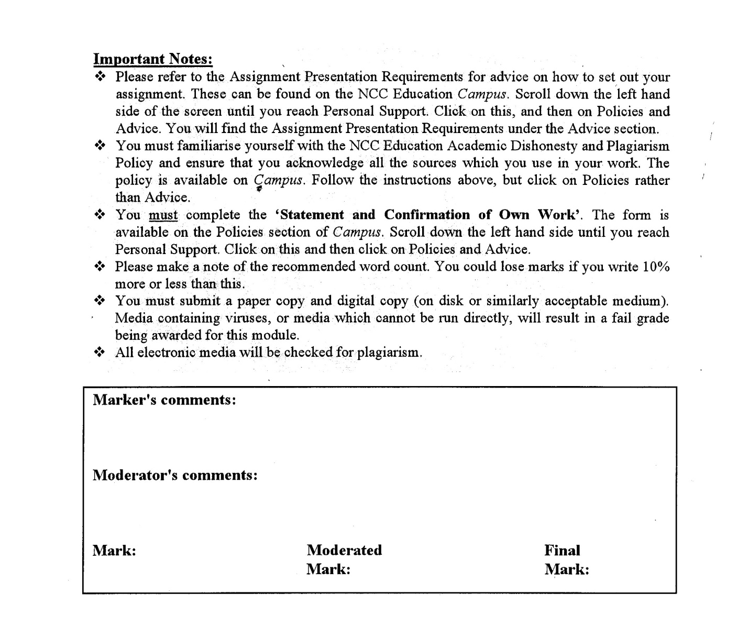



**Statement and Confirmation of Own Work**

**Programme/Qualification name: L4DC**

***All NCC Education assessed assignments submitted by students must have this statement as the cover page or it will not be accepted for marking. Please ensure that this statement is either firmly attached to the cover of the assignment or electronically inserted into the front of the assignment.***

**Student declaration**

**I have read and understood NCC Education’s Policy on Academic Dishonesty and Plagiarism.**

**I can confirm the following details.**

**Student ID/Registration number : 00189889**

**Name : NAME**

**Centre Name : KMD COMPUTER CENTRE (YANGON)**

**Module Name : Office Solutions Development**

**Module Leader : KHIN KHIN LAY KOON**

**Number of words : (2500) words**

**I confirm that this is my own work and that I have not plagiarized any part of it. I have also noted the assessment criteria and pass mark for assignments.**

**Due Date :** **February 2022**

**Student Signature : thihannaing**

**Submission Date : February 2022**

Table of Contents

Task 1 4

Application Software and Business Process 4

Task 2 6

End User Development 6

Task 3 7

Advanced features and functions of Microsoft Word 7

Task-4 8

Advanced features and functions of Microsoft Excel 8

References 9

References 10

# Task 1

## Application Software and Business Process

Finance and Charity

Financing take a huge role in charity because the charity is established with donators’ money. So, to keep the charity runs, the money management is very important. Financer have to protect the charity’s money, have to know the charity’s financial position, deals with financial problems as fast as possible, must accurate financial records and manage payments to trustees. (Commision, 2020)

Advertising and Charity

Advertising is necessary in a charity. The organization can advertise on Social Media, having Email Campaigns, with the help of Influencers, making Blogs and making partnerships. (Morris, 2019). Charity advertising try to motivate donators to give either time or money. By advertising or appreciating the donator’s company or name, they would like to donate more rather than the normal. (Kim, 2015)

Marketing and Charity

Marketing is important in every organizations and fields. And yet the charities nowadays should have marketing plans. Some of the marketing ideas are making sponsor or co-sponsor a charitable event, creating a special and limited edition products and selling those products, making a charity auction, making events showing the effectiveness of a charity. (Matisha, 2013)

Human resource and Charity

To establish an organization, HR role is essential. The HR team provide advice to both employees and management. HR have responsibility for different employment functions like compliance with employment law, pay and benefits, recruitment and training, employee relations and their health and safety. (Heffernan, 2018).

Management and Charity

Mangers in charity have most responsibilities. They have to recruit, organize and inspire volunteers, build good relationships with major donors and companies, prepare and deliver presentations, manage the own budget and ensure the target are met, developing and organizing fundraising campaigns, events and auctions. (Hill, 2019).

Marketing should use bespoke software so that they can sell their products on their software freely. Advertising, HR, management and finance should use commercial software. In marketing, creating

Marketing, Advertising and finance will use commercial software. HR and management will use bespoke software. For marketing and advertising, it is better to advertise on others software or websites. To make bespoke software for this, it could be difficult and may take long time to become well-known software. So that advertising and marketing on commercial software like social media software are better and become more popular in nowadays. For finance, there are some useful and well-known commercial software are exist already. So, instead of creating an own software, it is better use commercial software and those commercial software use lower price than creating a bespoke software. For HR and management, even though there are some software for those, it is the better to make bespoke software. During creating bespoke software, client can tell the developer that the features he wants to use. Like about the entities in database, especially the back-end developments are separate in companies. The client should tell the developer about the system he wants to use and ask to make some better features than the commercial software because the software will be used by end-users which are going to be employees.

There are some useful commercial software for marketing, advertising and finance. In advertising, it is important to attract the people on the product. There are many ways to make that. Using photos, videos or with contents. To create photos or videos, software from adobe are popular and cheap. If u can crack, they are even free to use for lifetime. Like Adobe Photoshop, Adobe Premium Pro, Adobe After Effect are popular. By using those software, you are ready for advertising. Later advertising can be processed on the different platforms. Todays, advertising and marketing on social media are popular and effective. Using influencers, using ads on websites, using ads on videos are becoming more popular. In this case, social media like Facebook, YouTube and Tik Tok are most popular and there are many users on these platforms. The client can even use letter writing software like Focus Writer for the content creating. So it would be a good choice to advertise on those commercial platforms. So as a conclusion, recommendations commercial software are Adobe for creating contents of ads and social media software for marketing.

For finance, everyone knows that excel is the best choice. Some features like data filtering, data sorting, password protection, creating different charts (eg. pie charts), automatically edit the result, build-in formulae, adding headers and footers, finding and replacement can be done with command which is very comfortable, and formula auditing. (Anon., n.d.).

# 

# Task 2

## End User Development

End-user development

End-user development (EUD) or end-user programming (EUP) are activities and tools that allow end-user(people who are not software developers) to program computers. With the help of EUD users don’t need to be professional developer to easily use a computer program and software easily. (Scaffidi, n.d.).

The advantages of EUD are too many. EUD make end-users easier to use software with the lack of computer knowledge, it provides competitive advantage and users can tell the developers about the functions needed.

The disadvantages of EUD are that it can lead user away from their job, users don’t know how to solve technical issues, it can be duplicated and it can have integrations problems.

Analysis

The project begins with analysis on the client data. In this case, the communication between stakeholders and developers must facilitate to create good software. Analysis needs to take data and information from the client. It is clear that client want to safe cost so analysis shouldn’t make it cost too much. After that analysis should test the right and suitable data before designing it. (Global, n.d.)

Design

Designing the software is important because it is the place that users are going to enjoy the software. User interface should be looking great. There are three types of software level design. 1 Architectural design, 2 High-level design, 3 Detailed design. Depend of the client the project should be design in one of those type. After choosing the suitable design, the project will be development. (Mindbrower, n.d.)

Implementation

Software implementation is the process of adopting and integrating software applications into a business. Depending on the industry or on the client, developers have to develop the software for the users. To implement the software successfully, developers should pre-test the software and install the software on various types of OS and various machines. They need to train end-users about the software and the employees of their companies. (Anon., n.d.).

Testing

The testing stage is essential for developing software. Before the users using it, the developers must testing the errors and bugs and if there any errors, it must need to be fixed. (Geeta, n.d.)

Documentation

The software documentation must include UI and UX, information Architecture and good understanding of the client. (Anon., 2021)

During the process of developing a software, there are steps that user are necessary to involved in the progress. During analysis the user should give the list of information that they going to need and the information that the developer ask. When it comes to design, the user need to be open-minded and tell the developer about the design that is wanted. If the user doesn’t know much about the design, the user should tell the developer about it clearly. If not, the unnecessary small problems will lead the big one. Implementation doesn’t need the user that much. But the user needs the guideline of the software usage from the developer. The step of testing doesn’t need the user because the user doesn’t know about the problem and don’t even know how to test. When developer shows the documentation, the user just need to watch and do nothing too much.

User Interface importance

During quarantine everyone stays at home so donating on the website are becoming more useful than normal and it is more convenient. In this case a good looking website is needed. So the charity need to make good UI website. User Interface (UI) is important to meet user expectations and shows the effectiveness of the functions of the website. The aim of good UI is to make the UX (user’s experience) easy and intuitive, minimum effort on the user’s part and maximum desire outcome. (Team, 2021).

# 

# Task 3

## Advanced features and functions of Microsoft Word

1. Select start mail merge and choose step by step mail merge wizard.

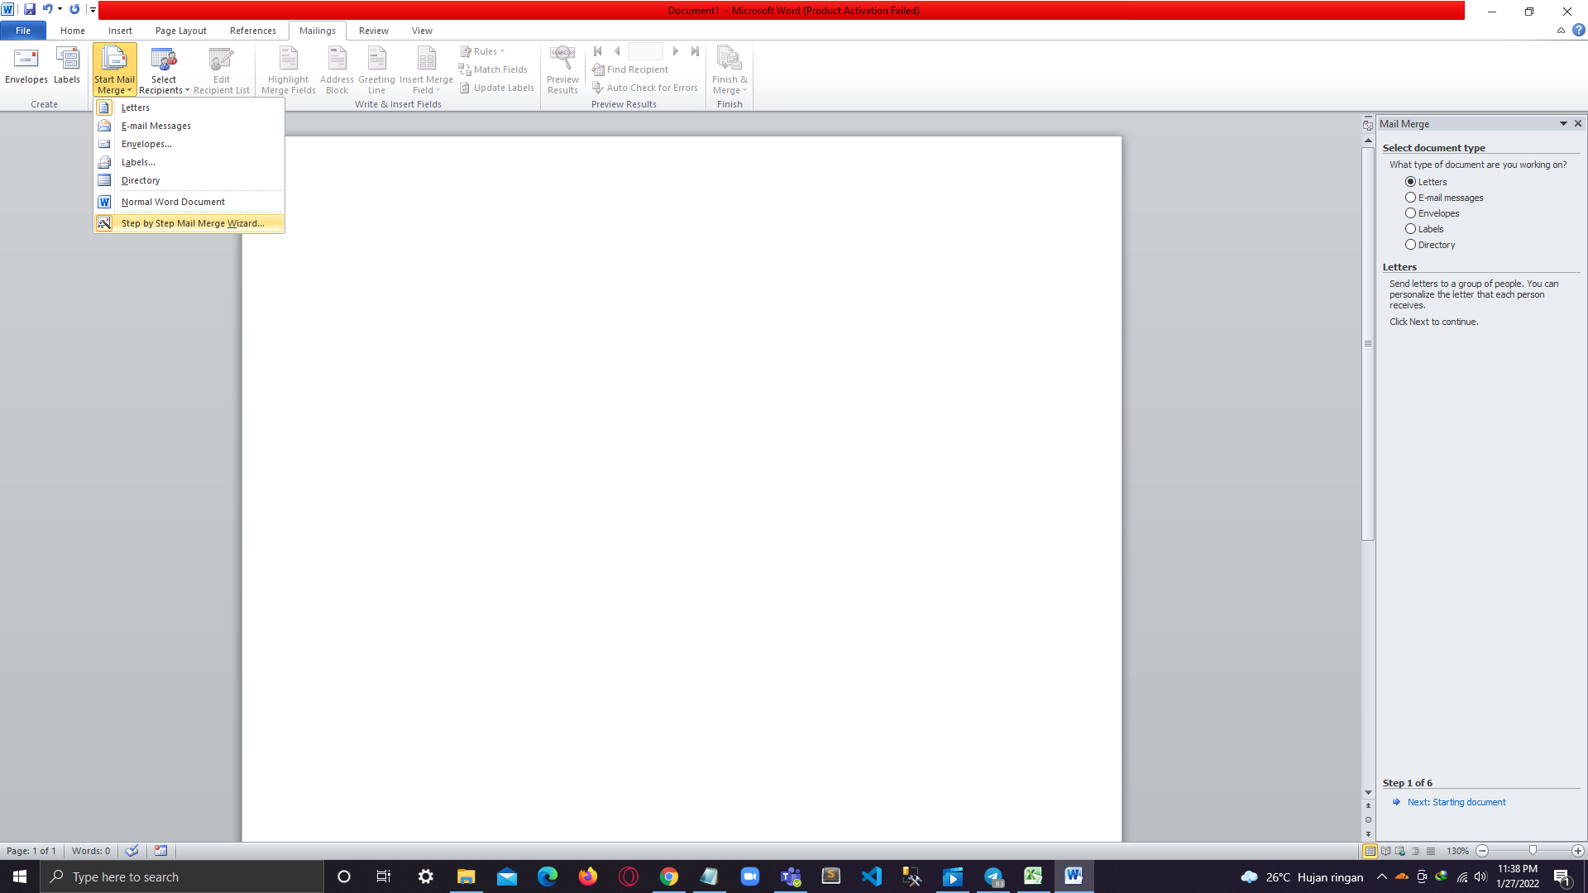

1. Write the address of the charity and choose date and time from Insert .

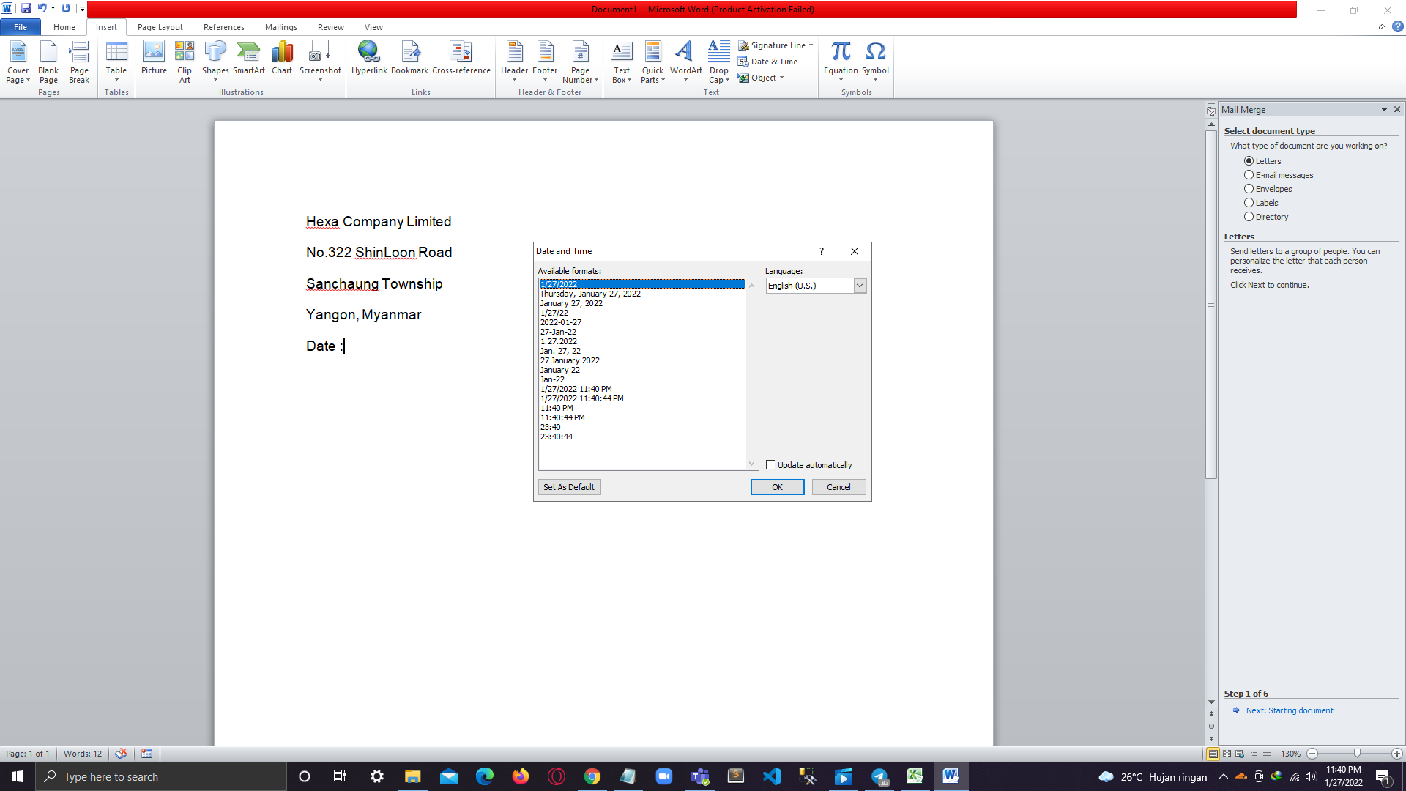

1. Choose letter and go to the next page.

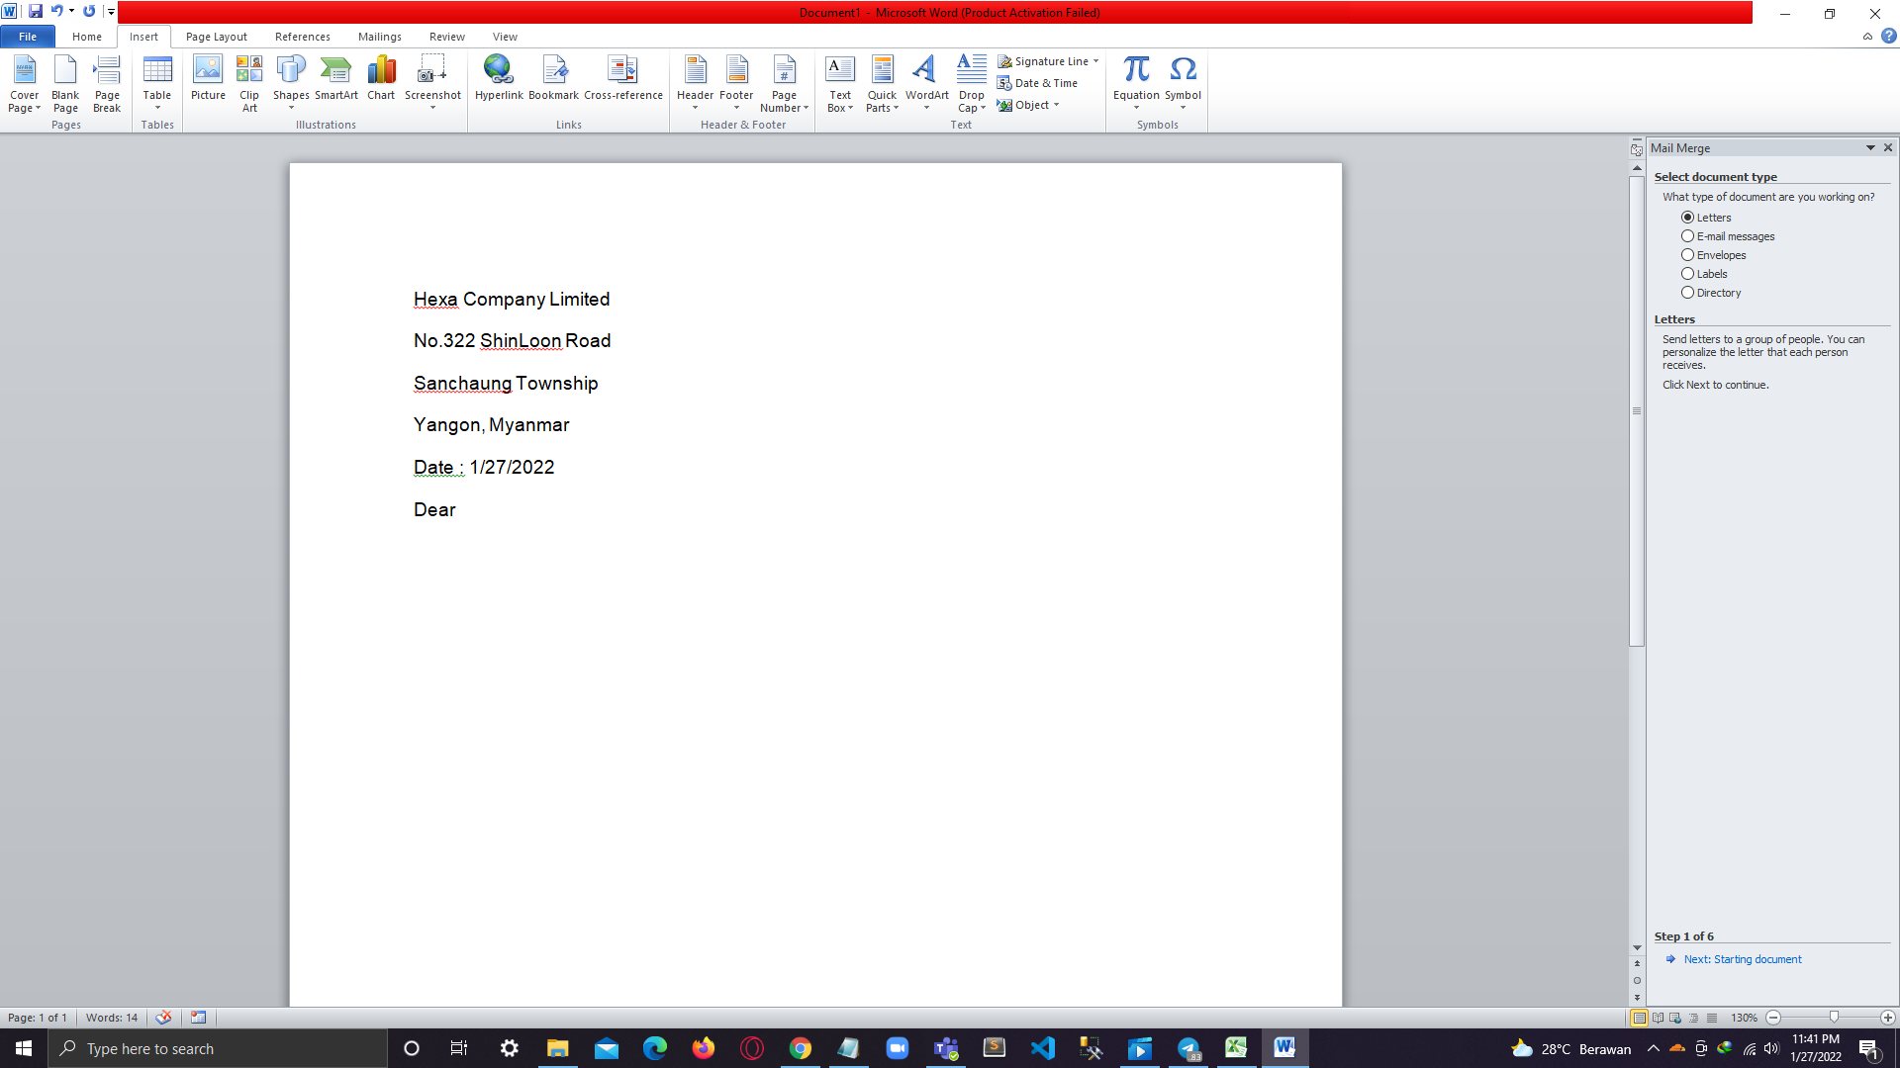

1. Choose use current document and click next recipients.

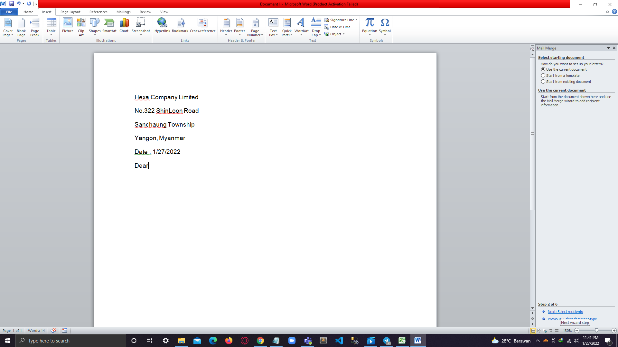

1. Find the excel folder.

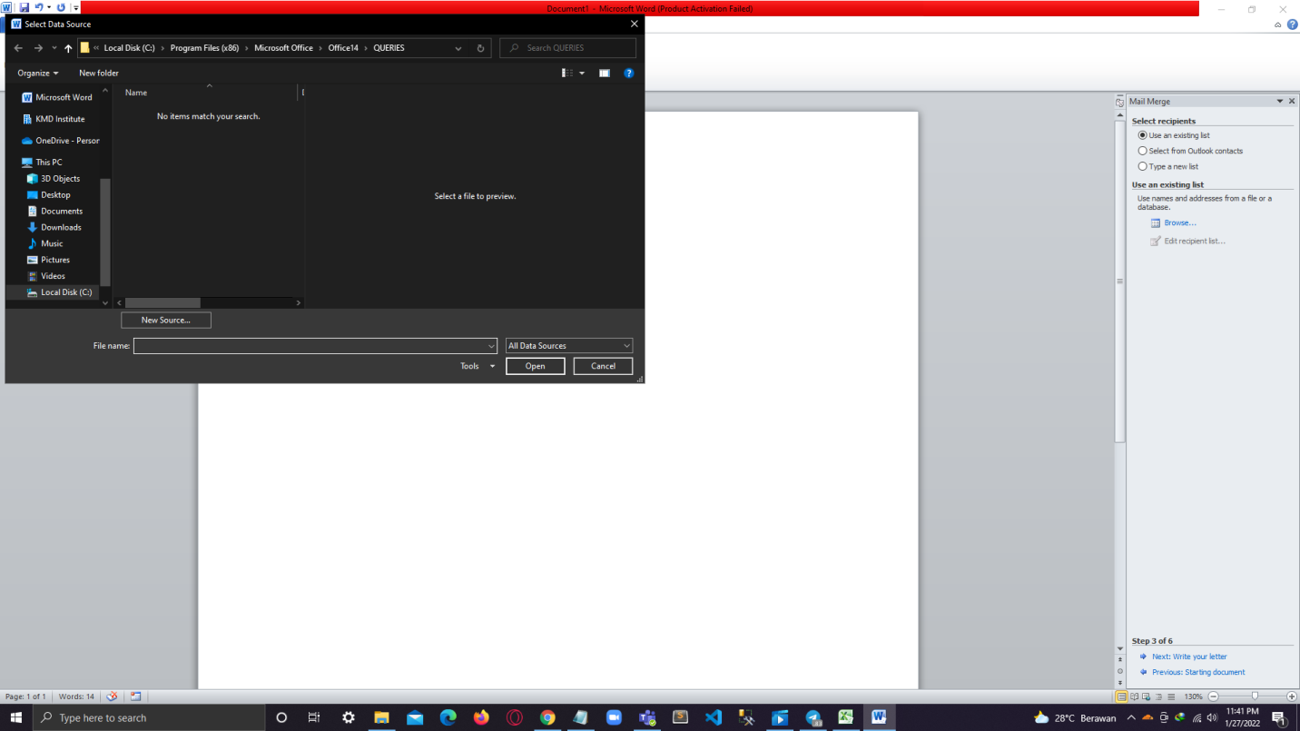

1. Choose the file which already added the recipient names.

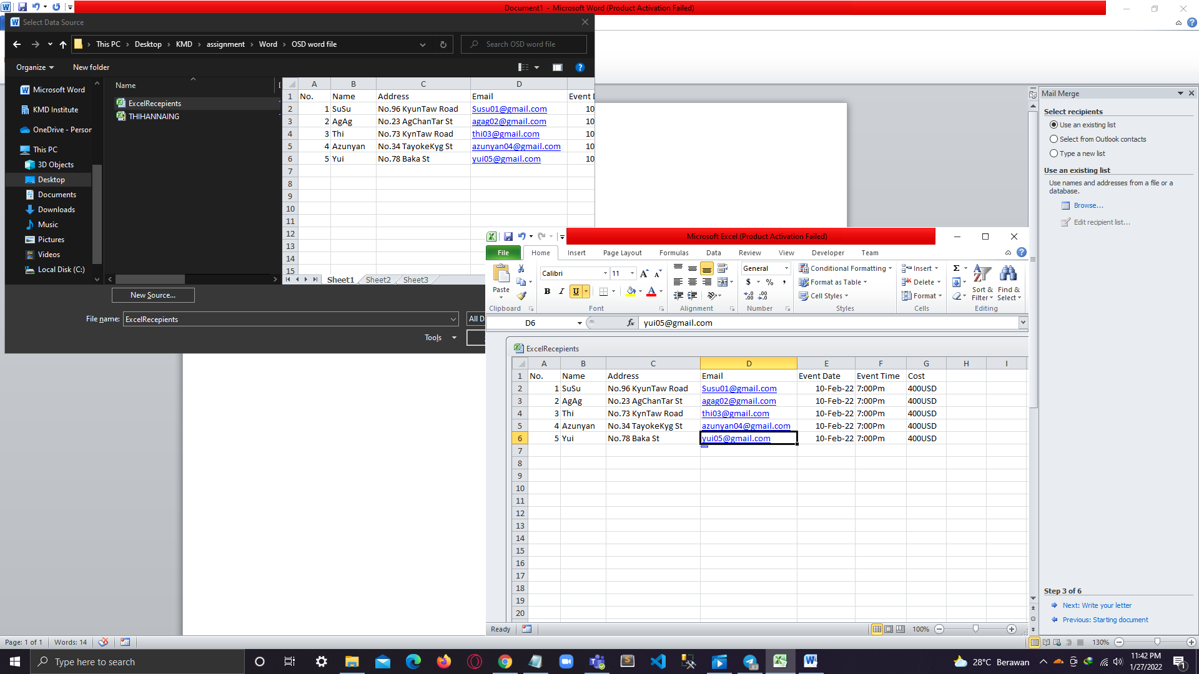

1. Then select it.

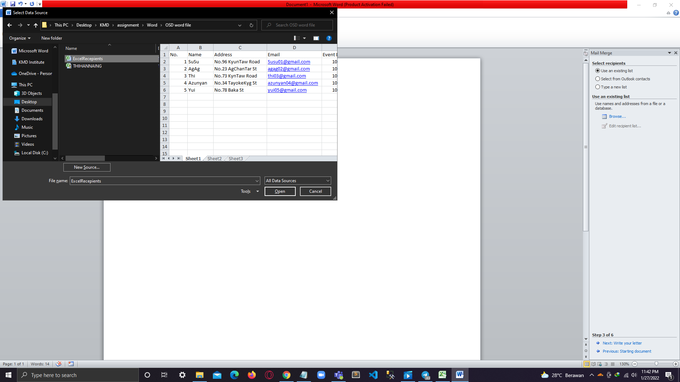

1. Click Ok.

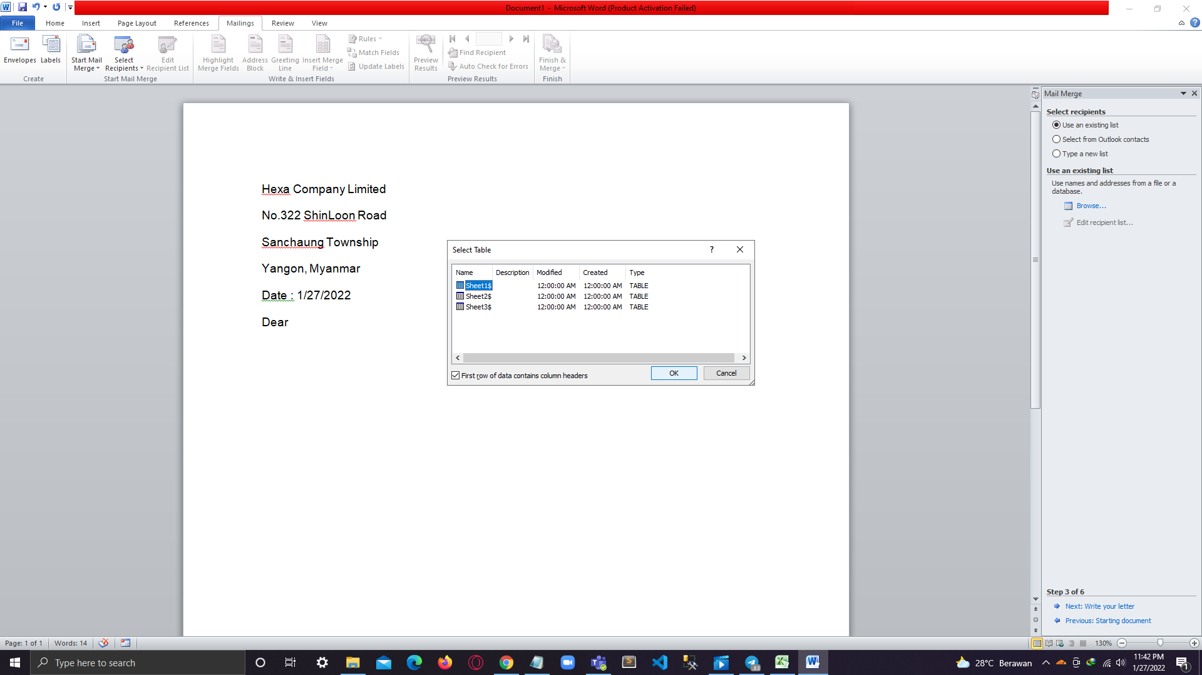

1. Click ok.

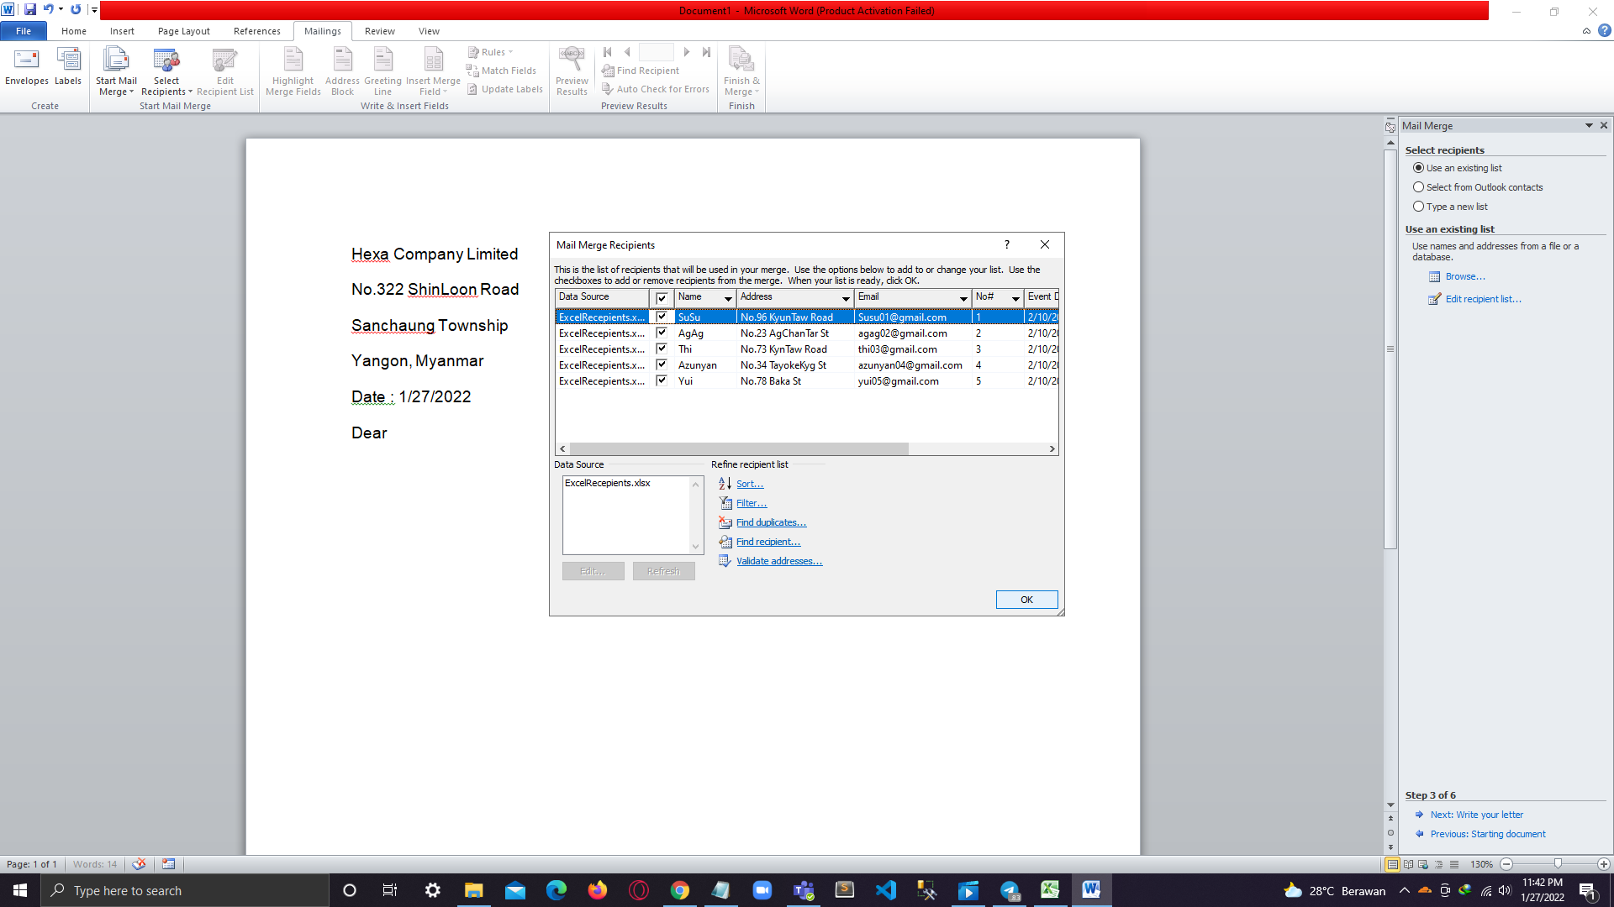

1. Select insert merge field.

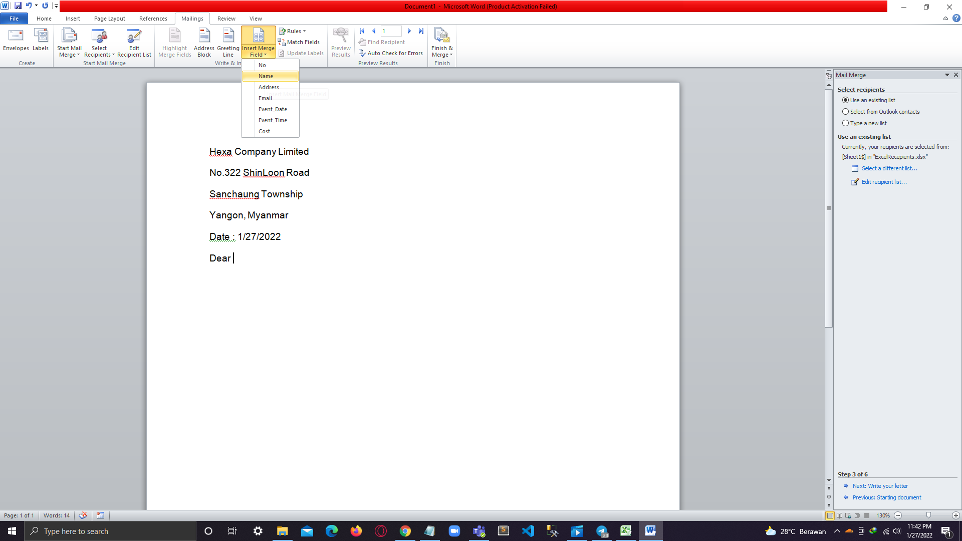

1. Select mail name.

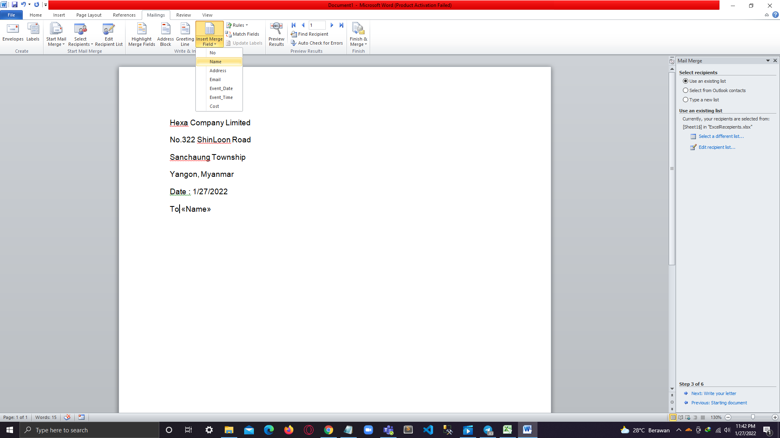

1. Select mail address.

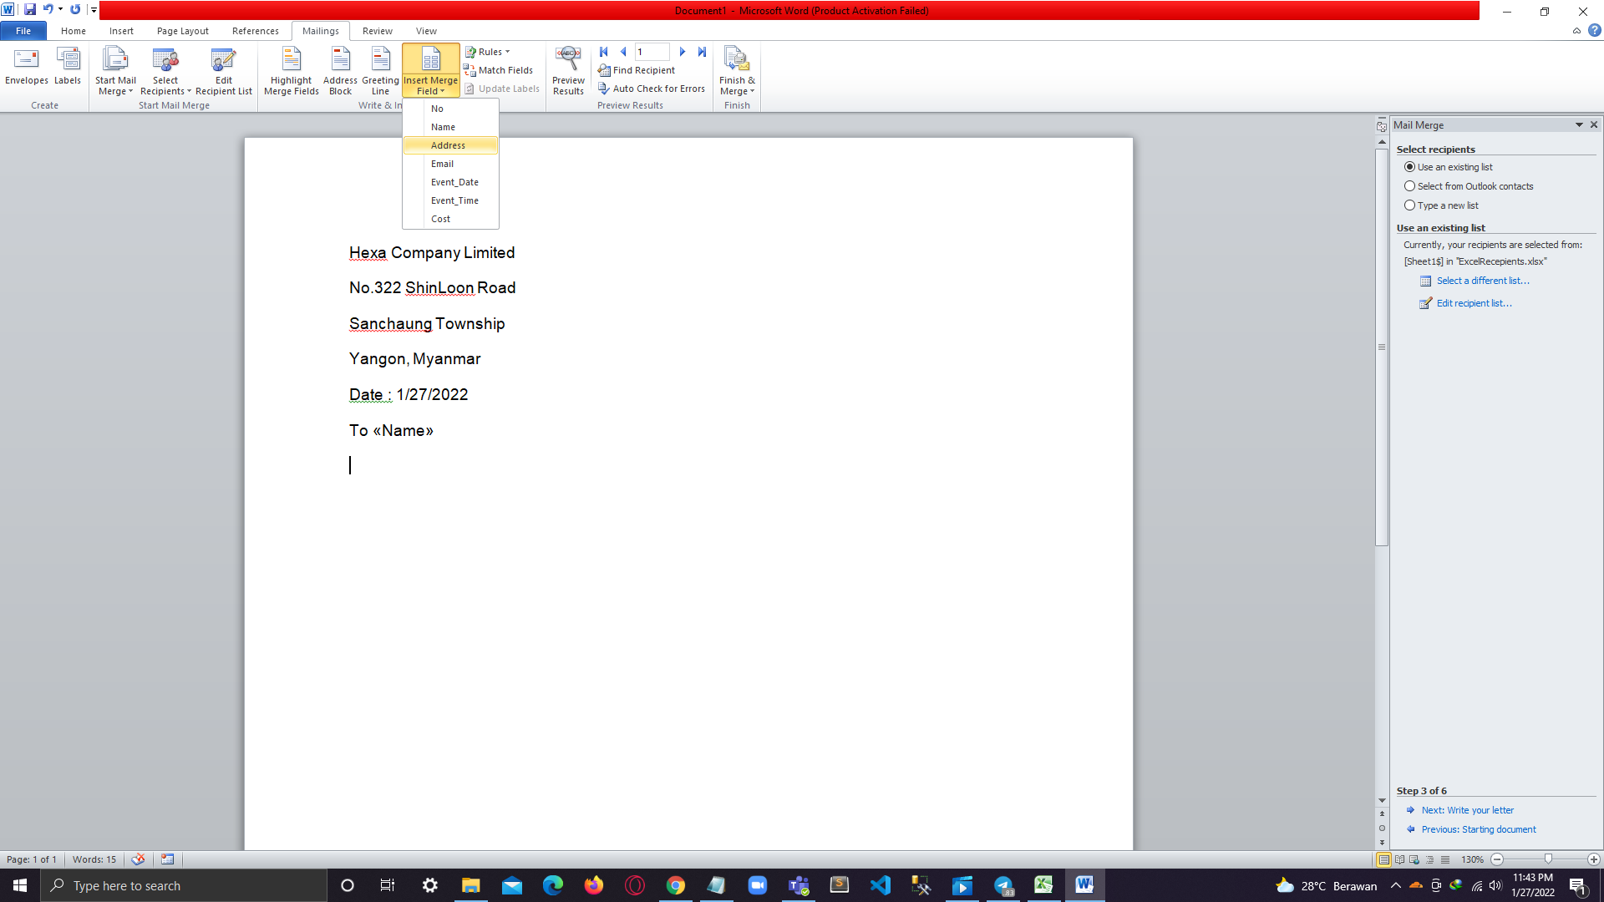

1. Select mail Email.

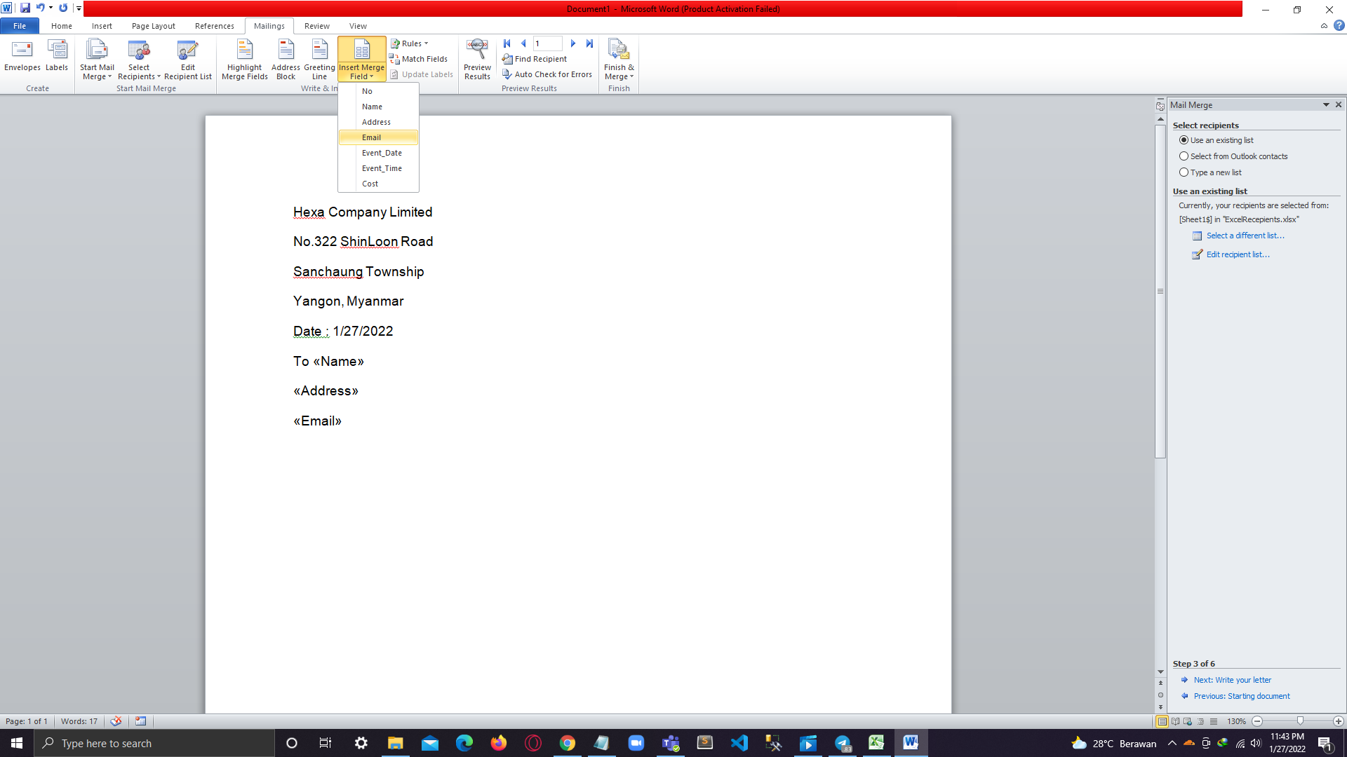

1. Add the inviting paragraph and event detail mail

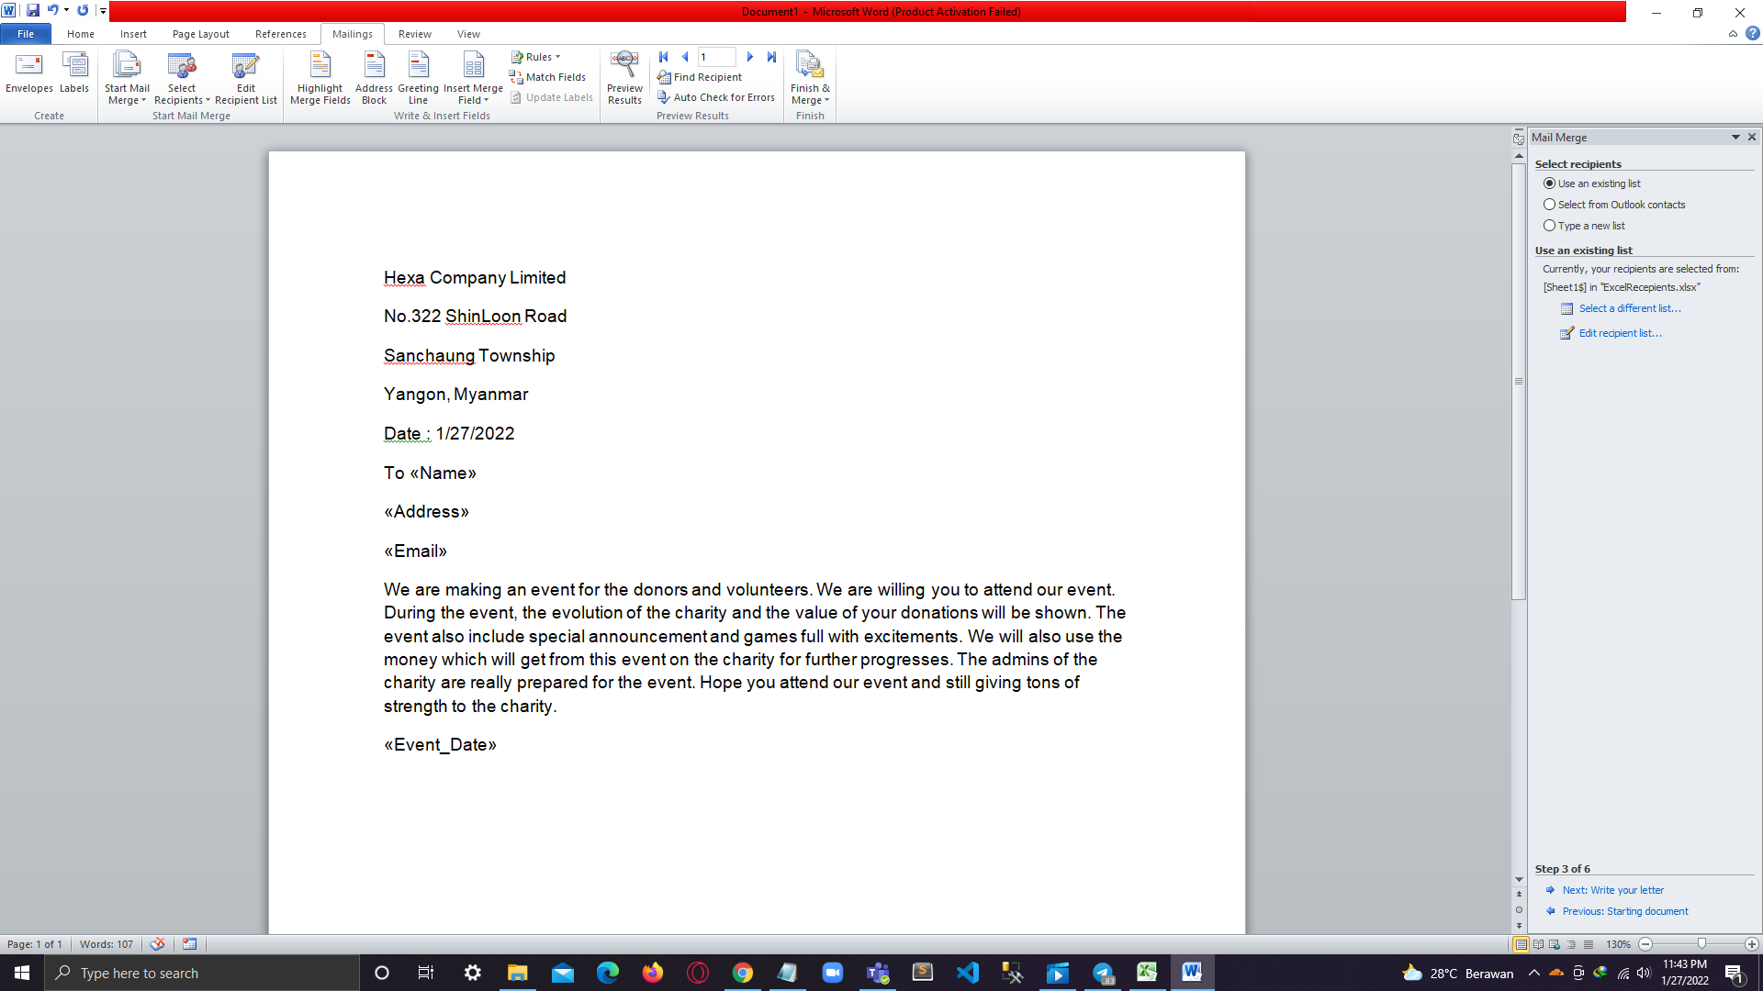

1. Select event time.

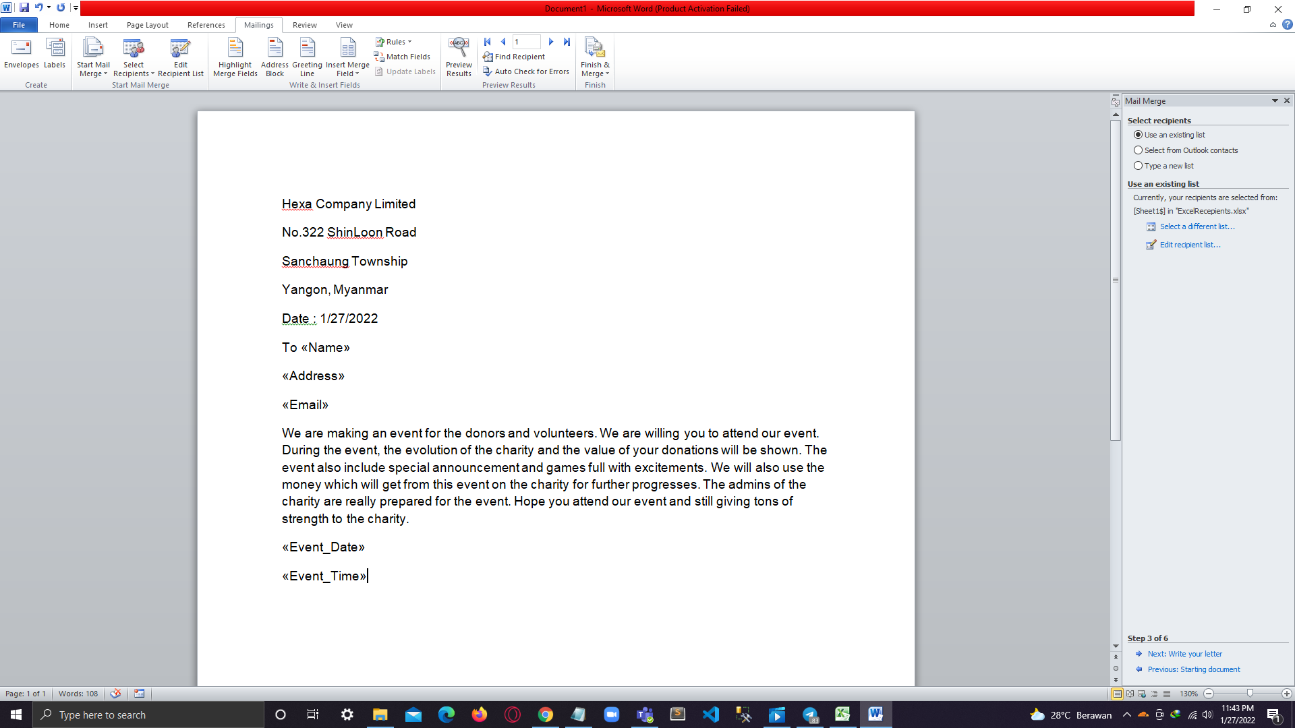

1. Select Costs.

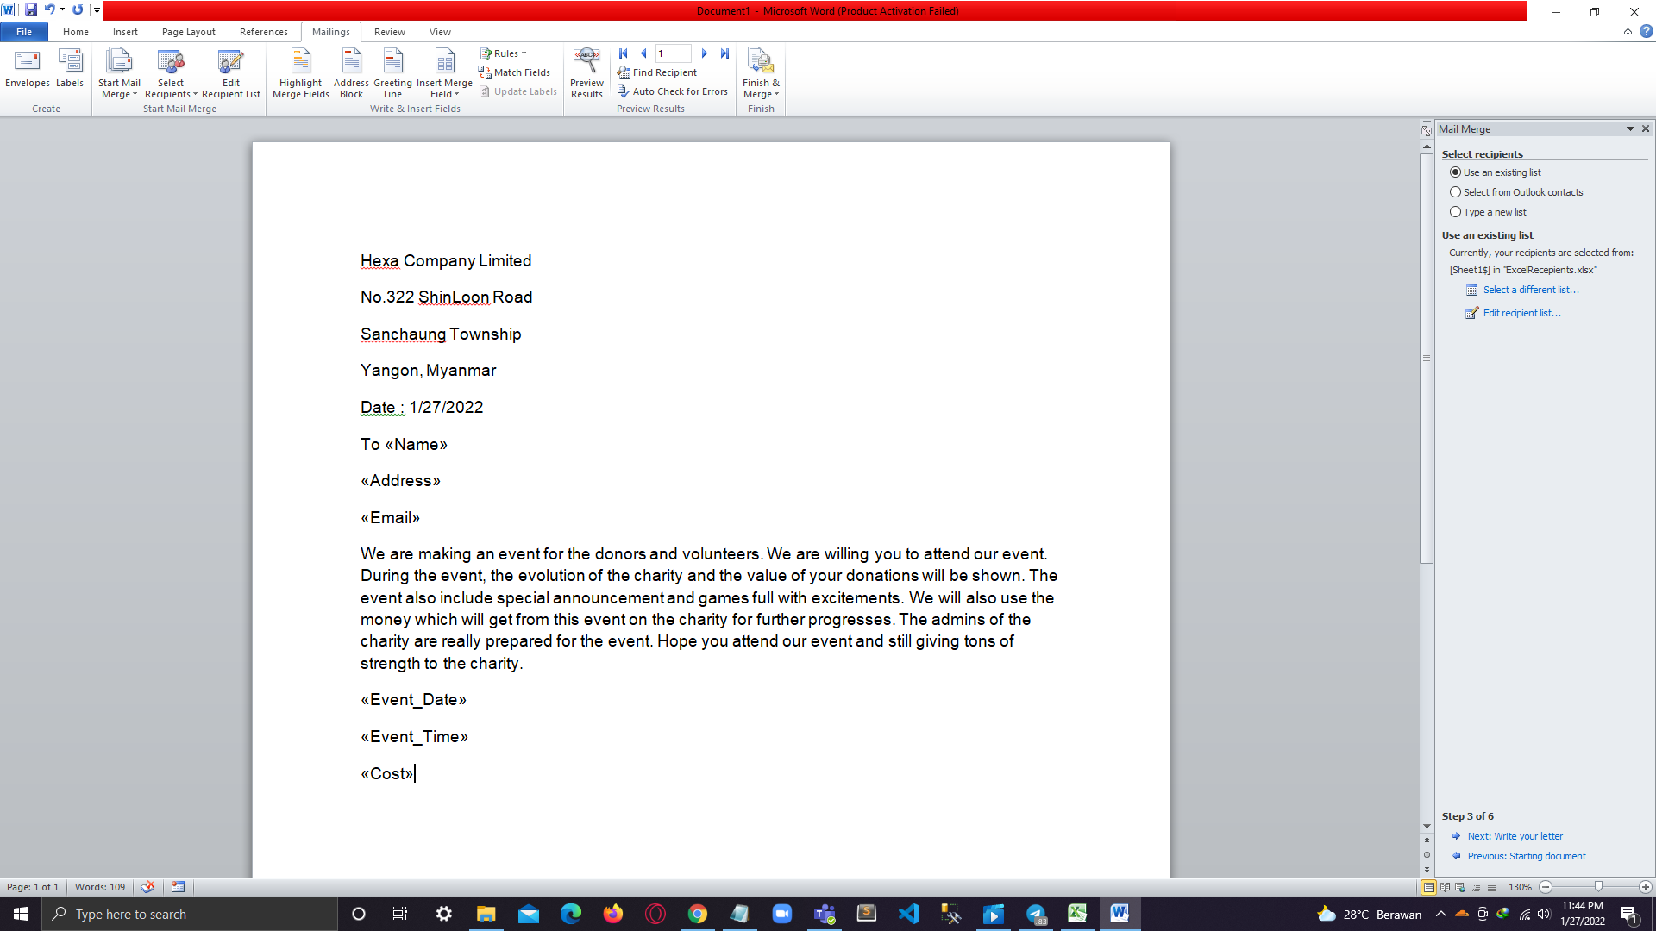

1. Write conclusion.

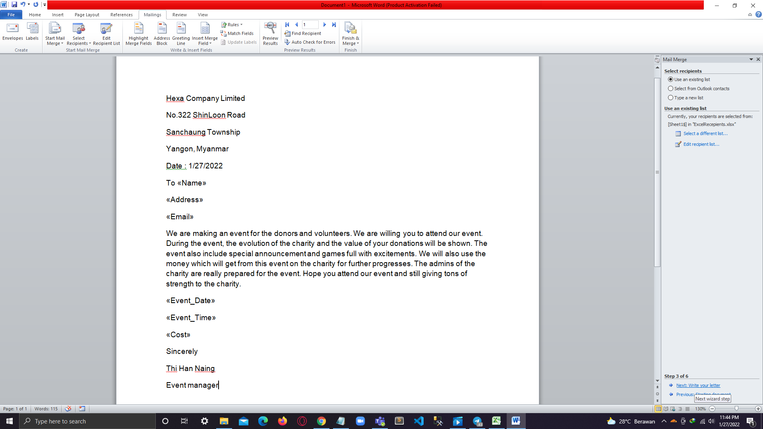

1. Click for next page.

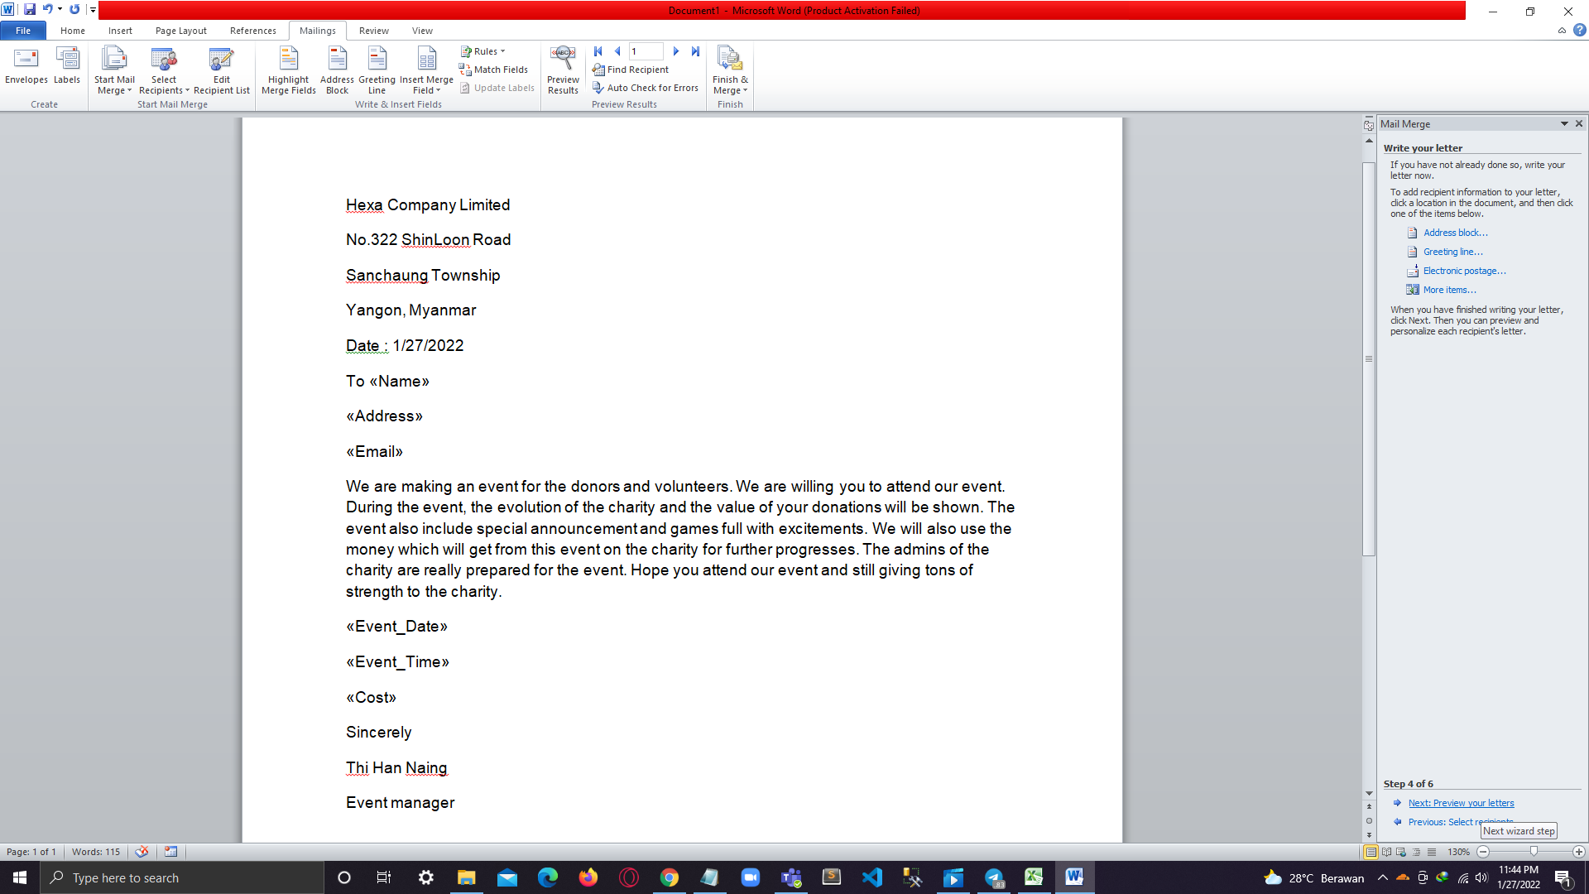

1. Recipient 1.

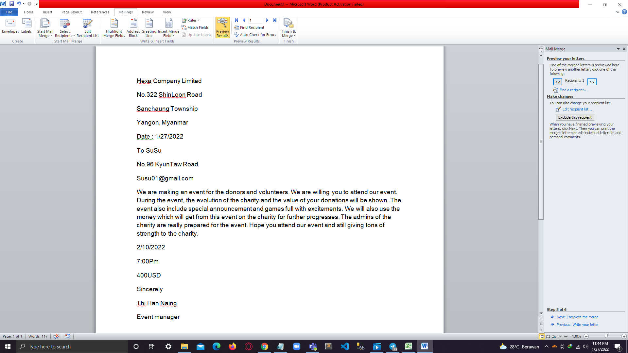

1. Second Recipient.

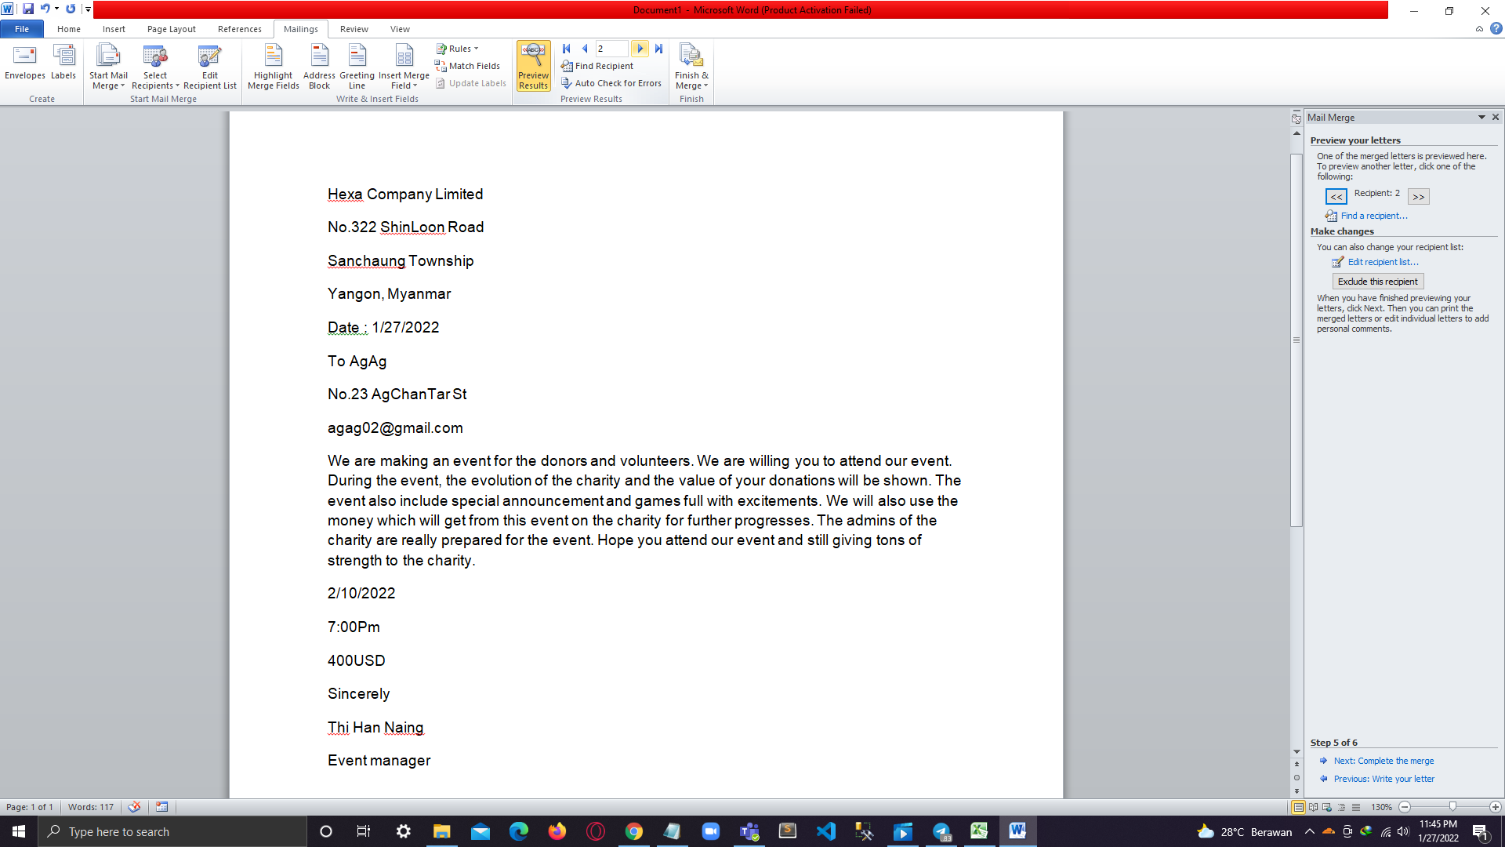

1. Third Recipient.

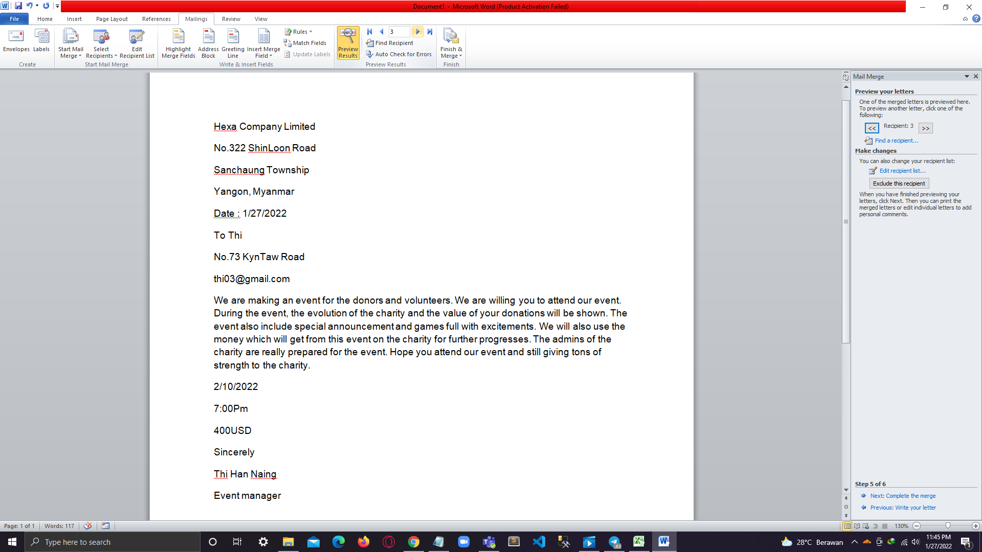

1. Recipient 4.

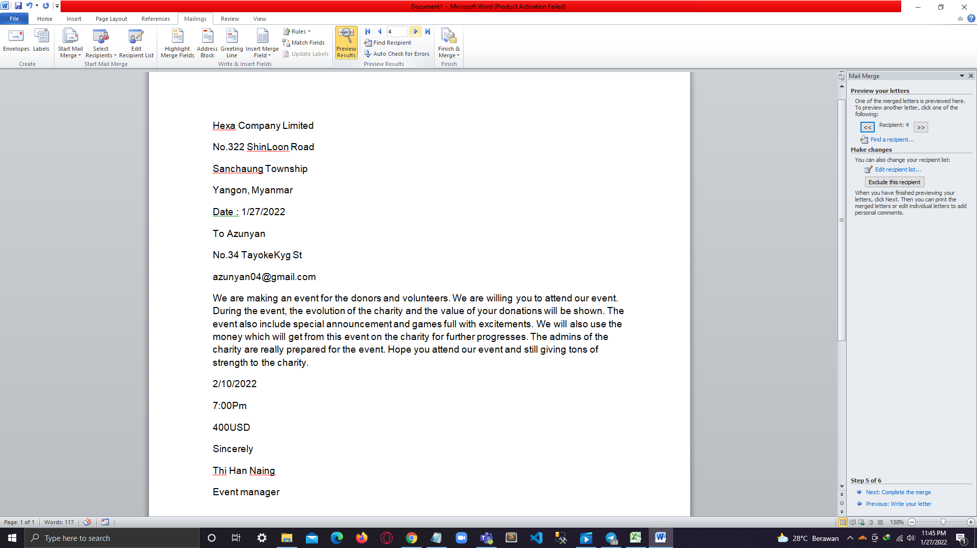

1. This is fifth recipient and can complete the merge.

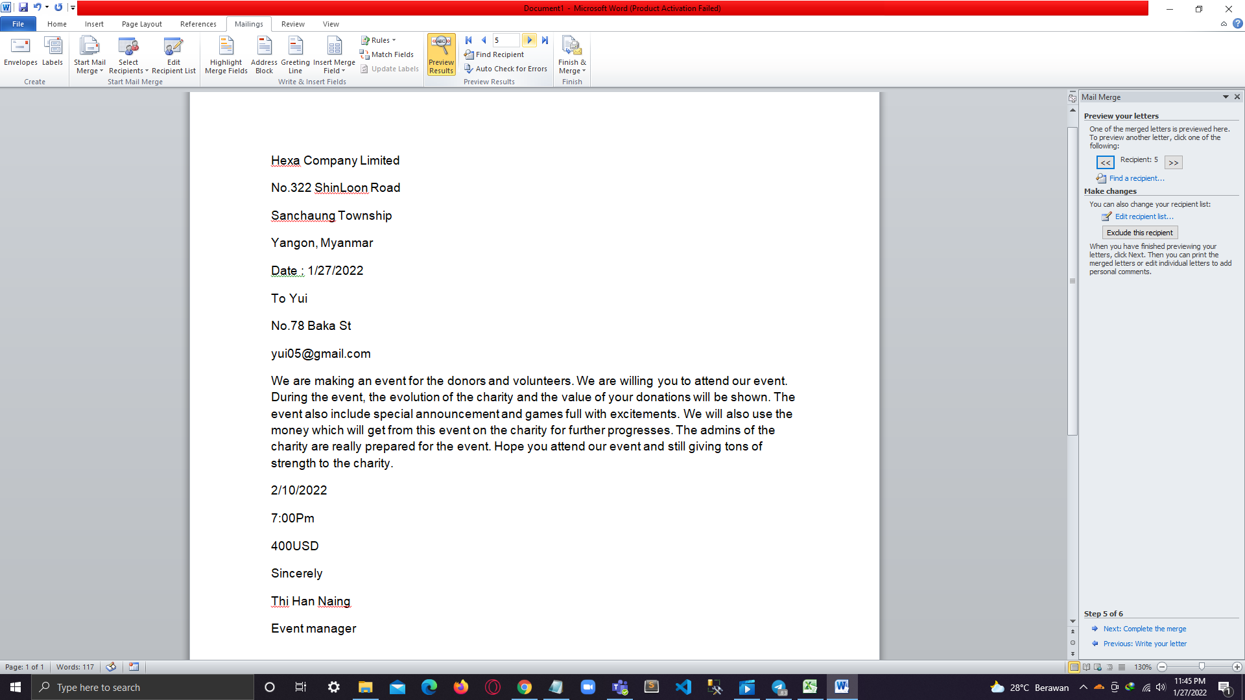

# 

# Task-4

## Advanced features and functions of Microsoft Excel

1. Choose radio button for income.

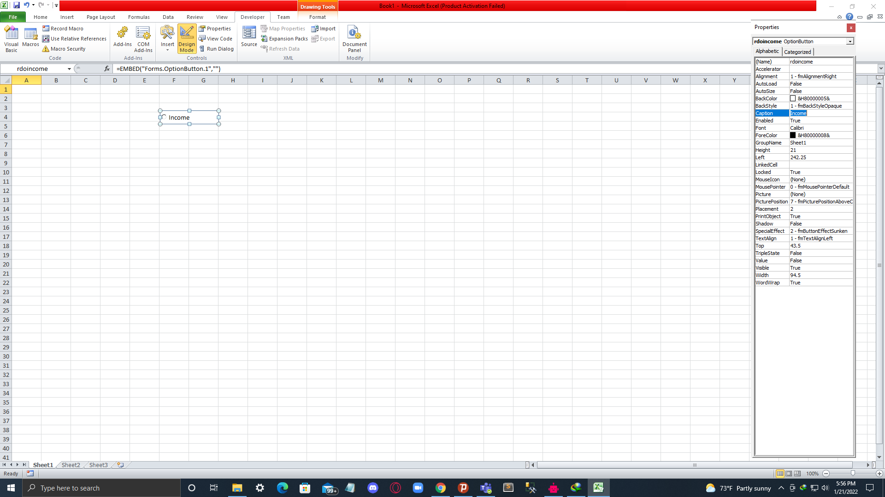

1. And for the expense too.

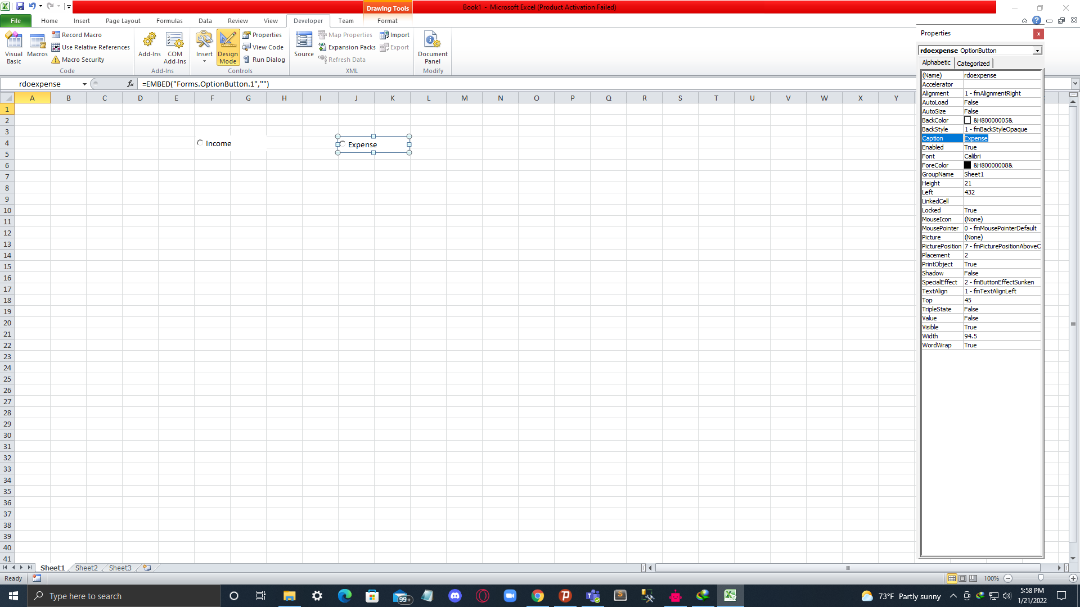

1. Take Label and text box for Name.

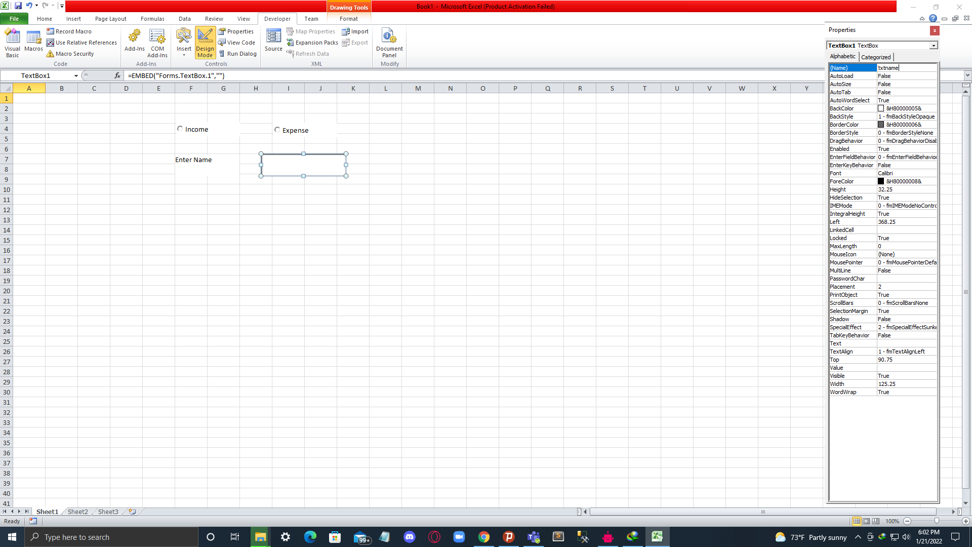

1. Take text box for amount.

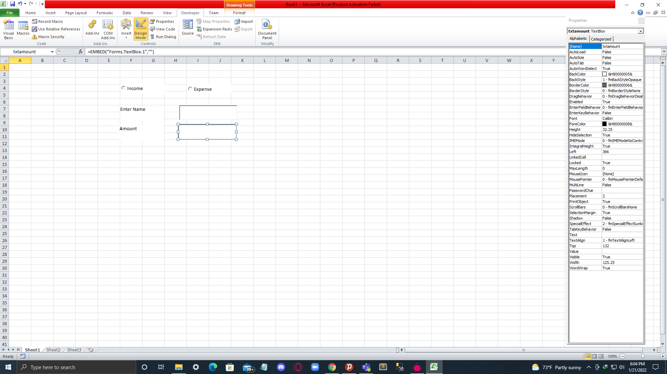

1. Label for amount.

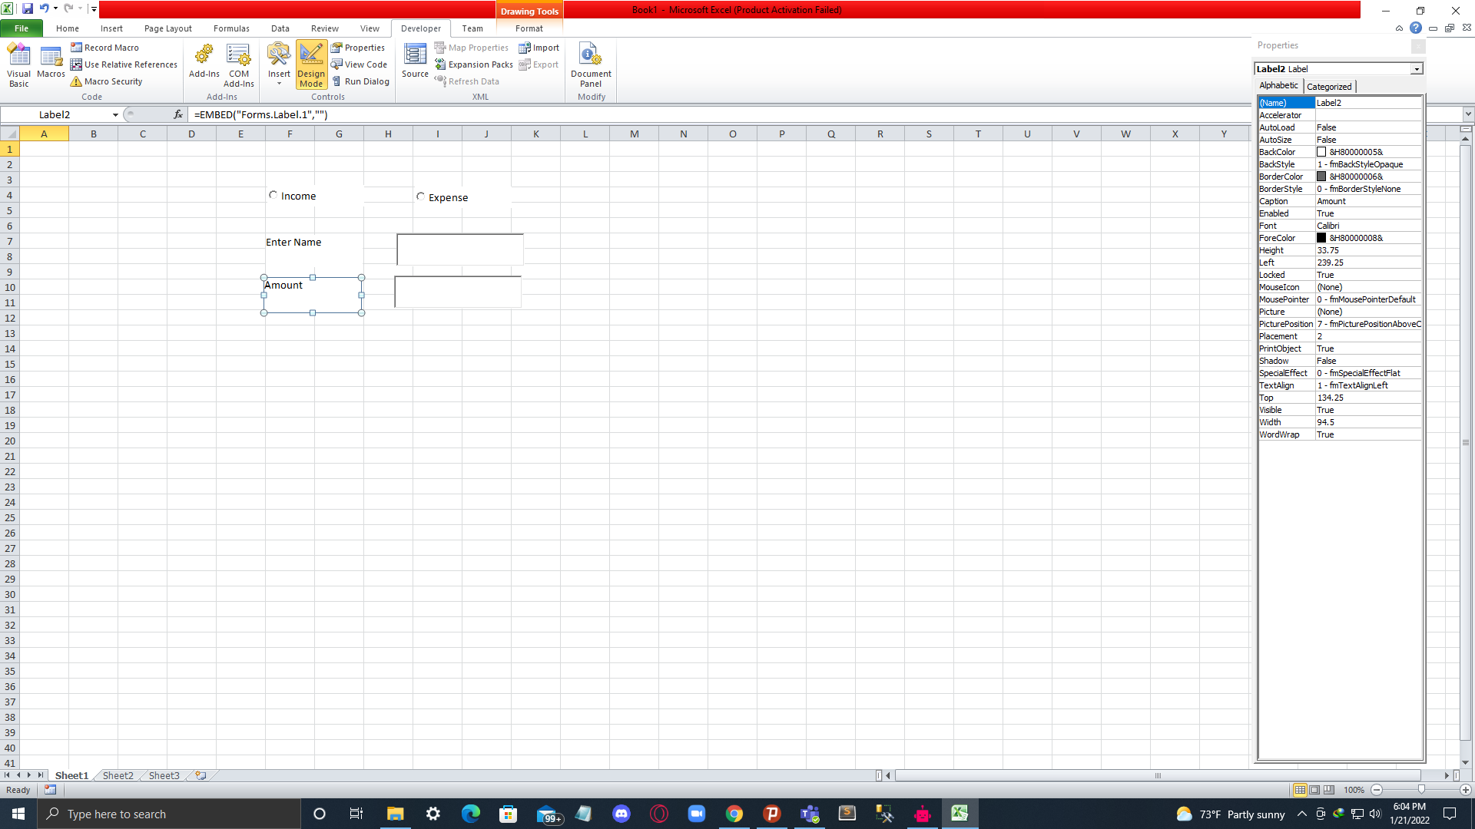

1. Label for cost.

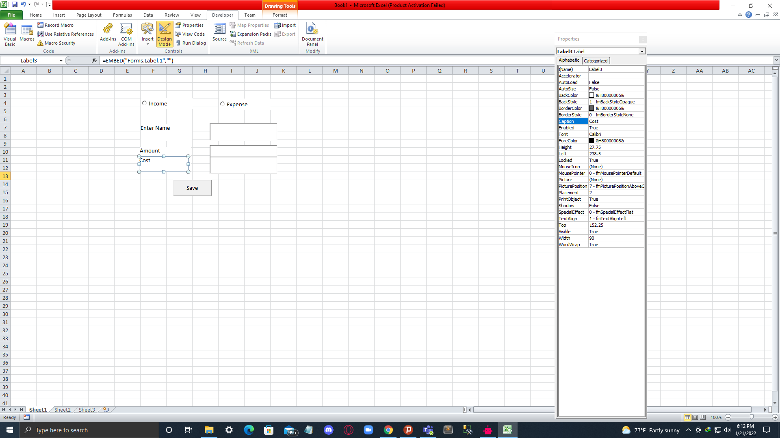

1. Text box for cost.

# 

1. Button for saving. Name as save button.

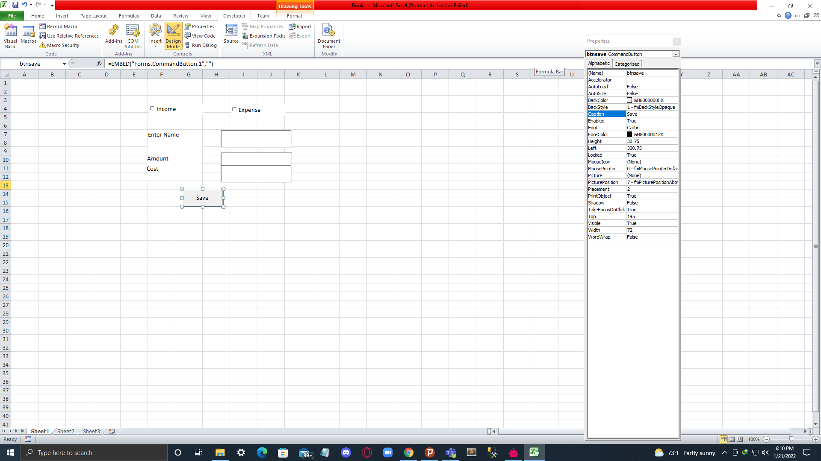

1. Button for expense.

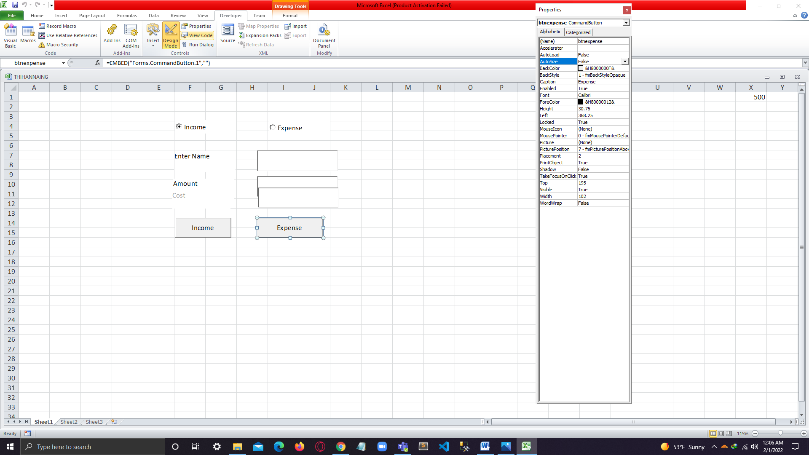

1. Complete design.

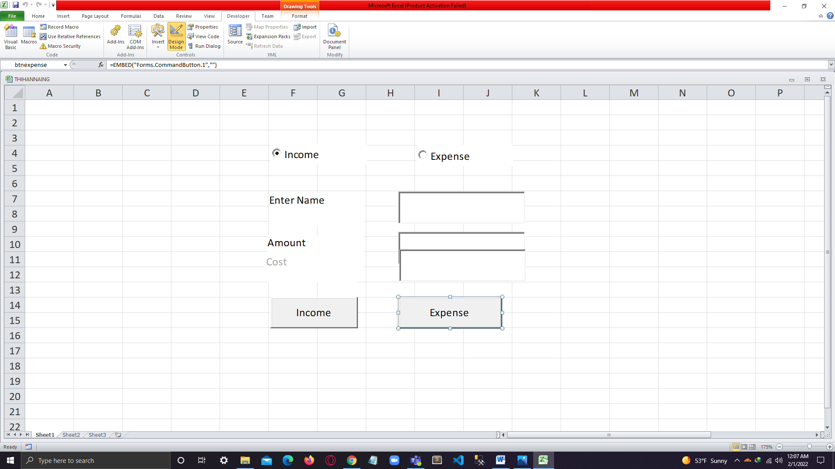

1. The code for the design.

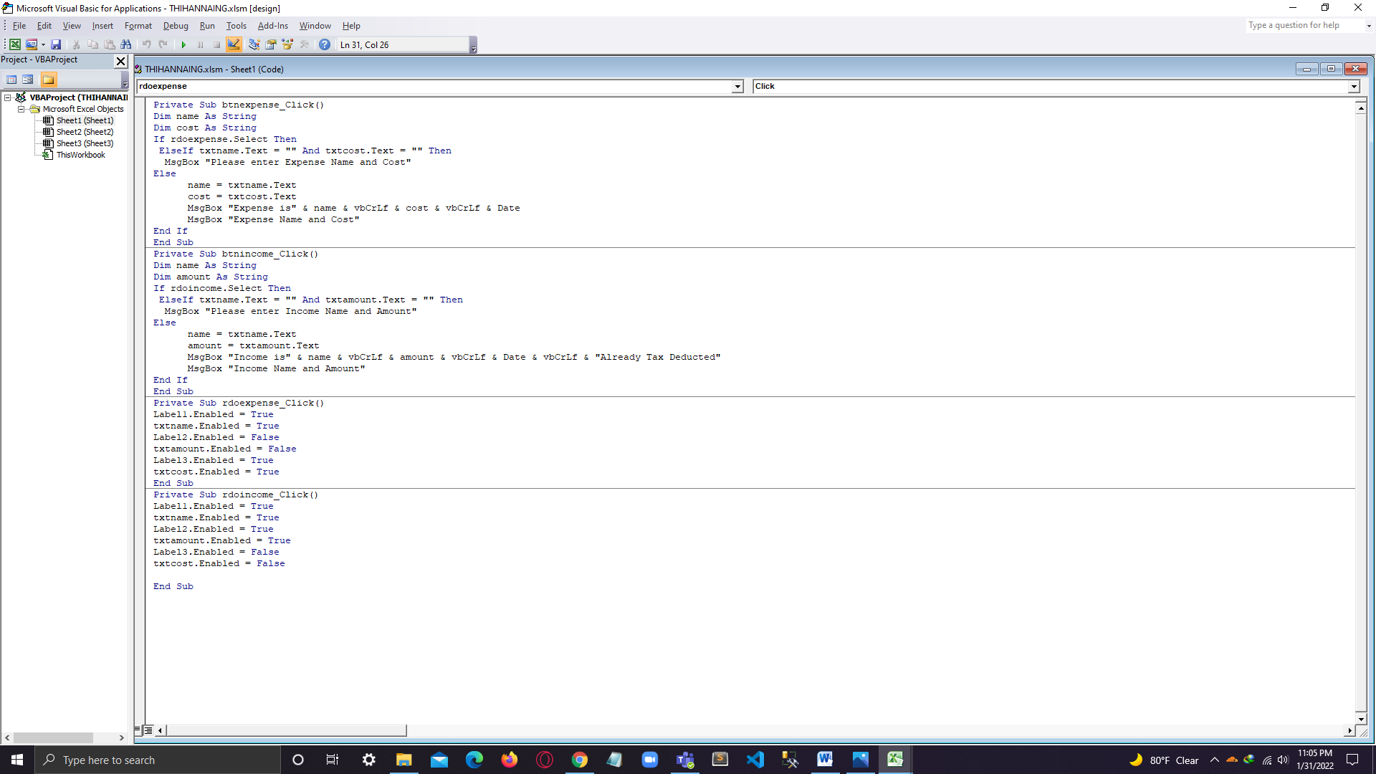

1. Showing the message about without adding any data when clicking income button.

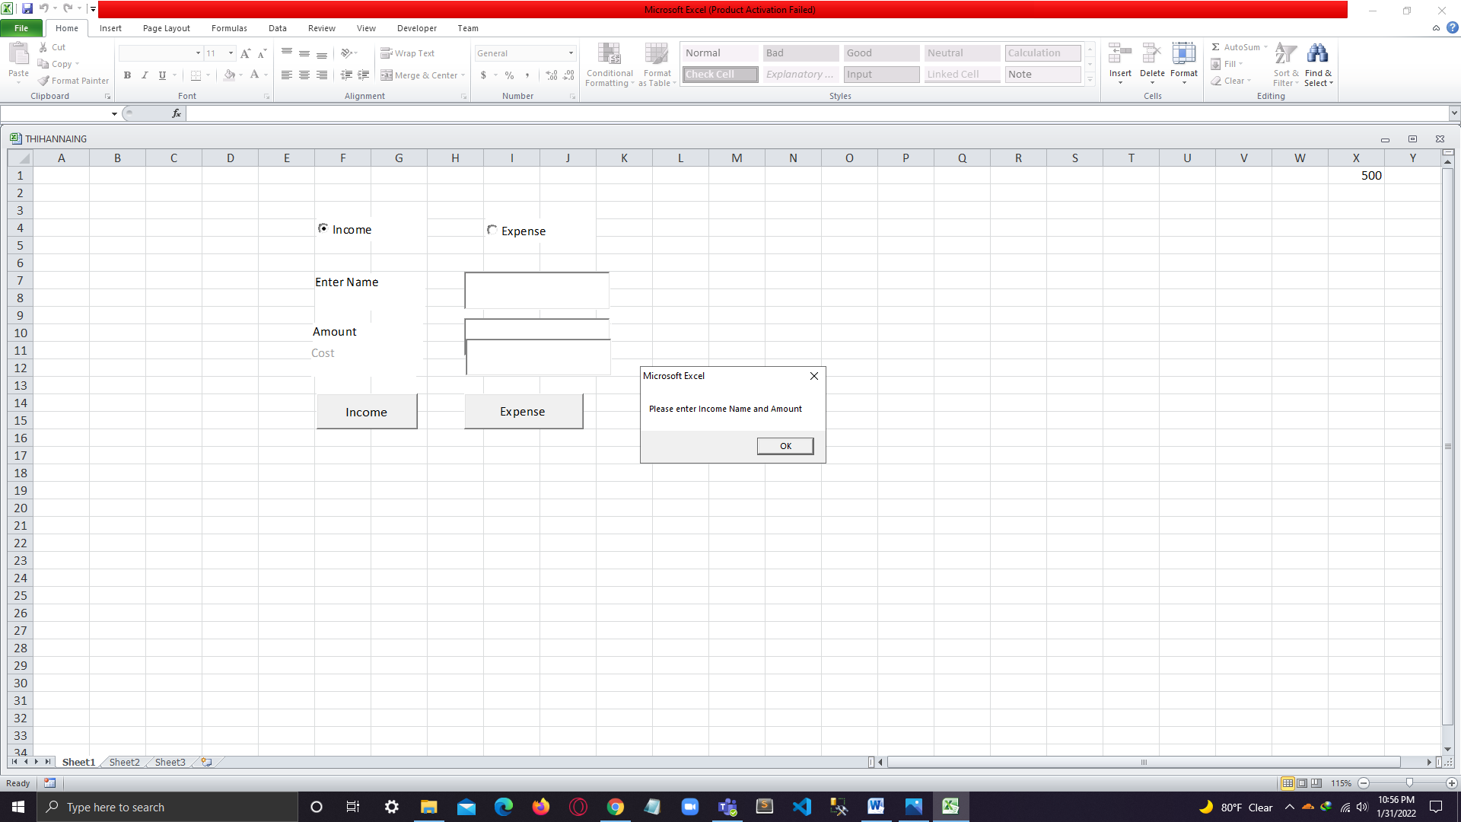

1. Showing the message about without adding any data when clicking expense button.

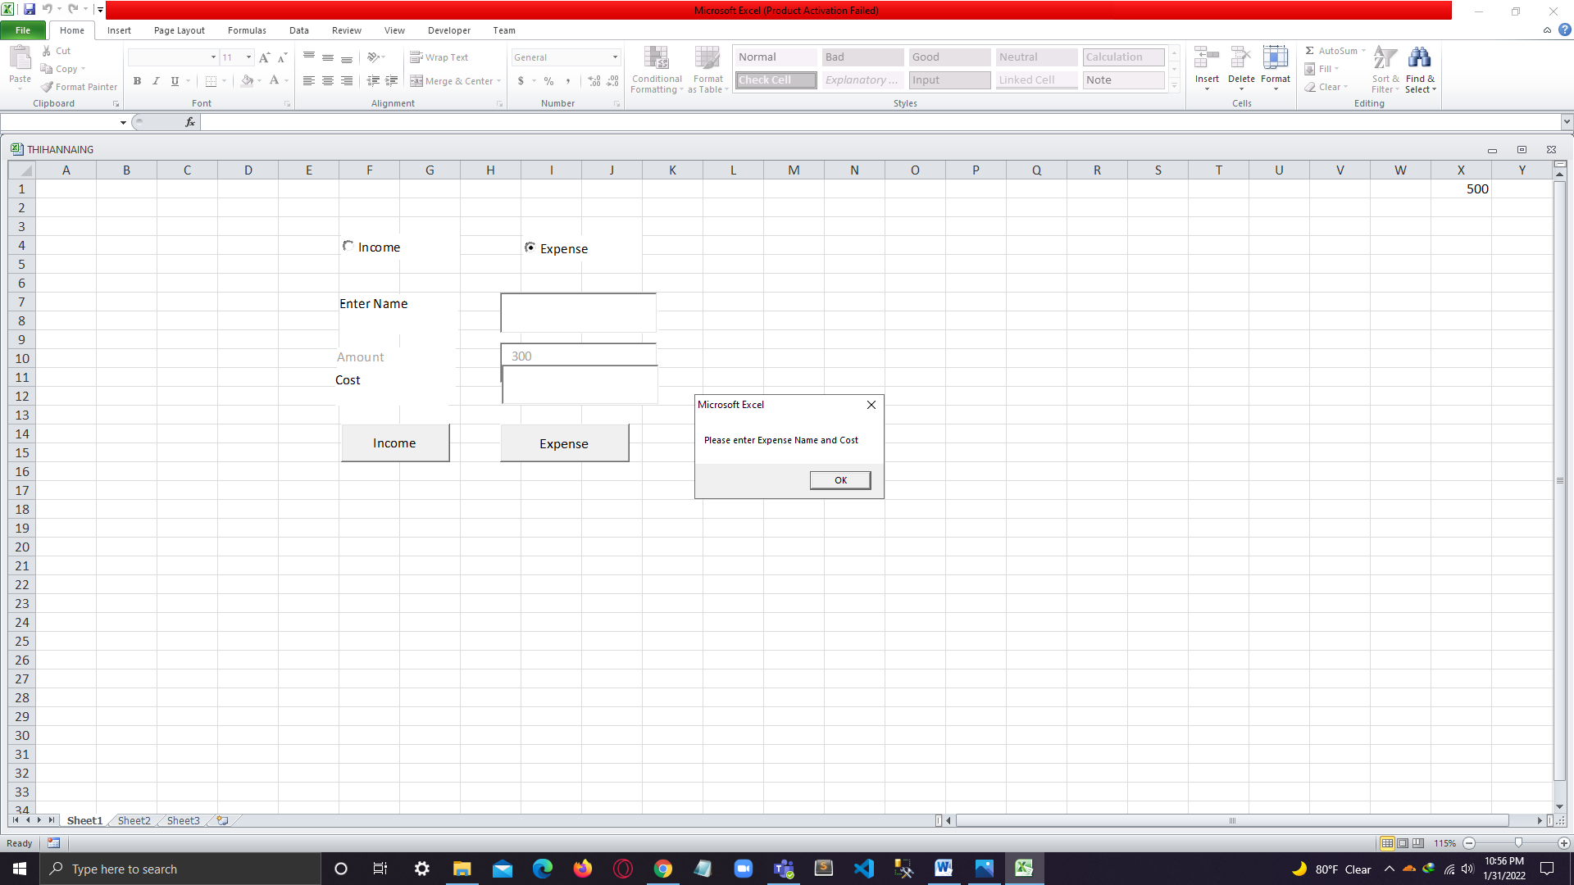

1. Adding data and showing the message box when clicking the income button.

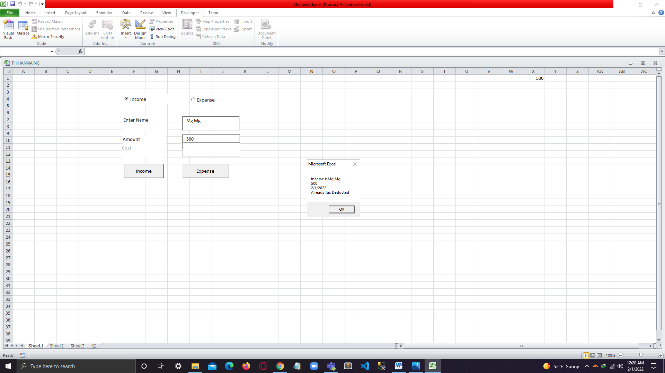

1. Replying income message box.

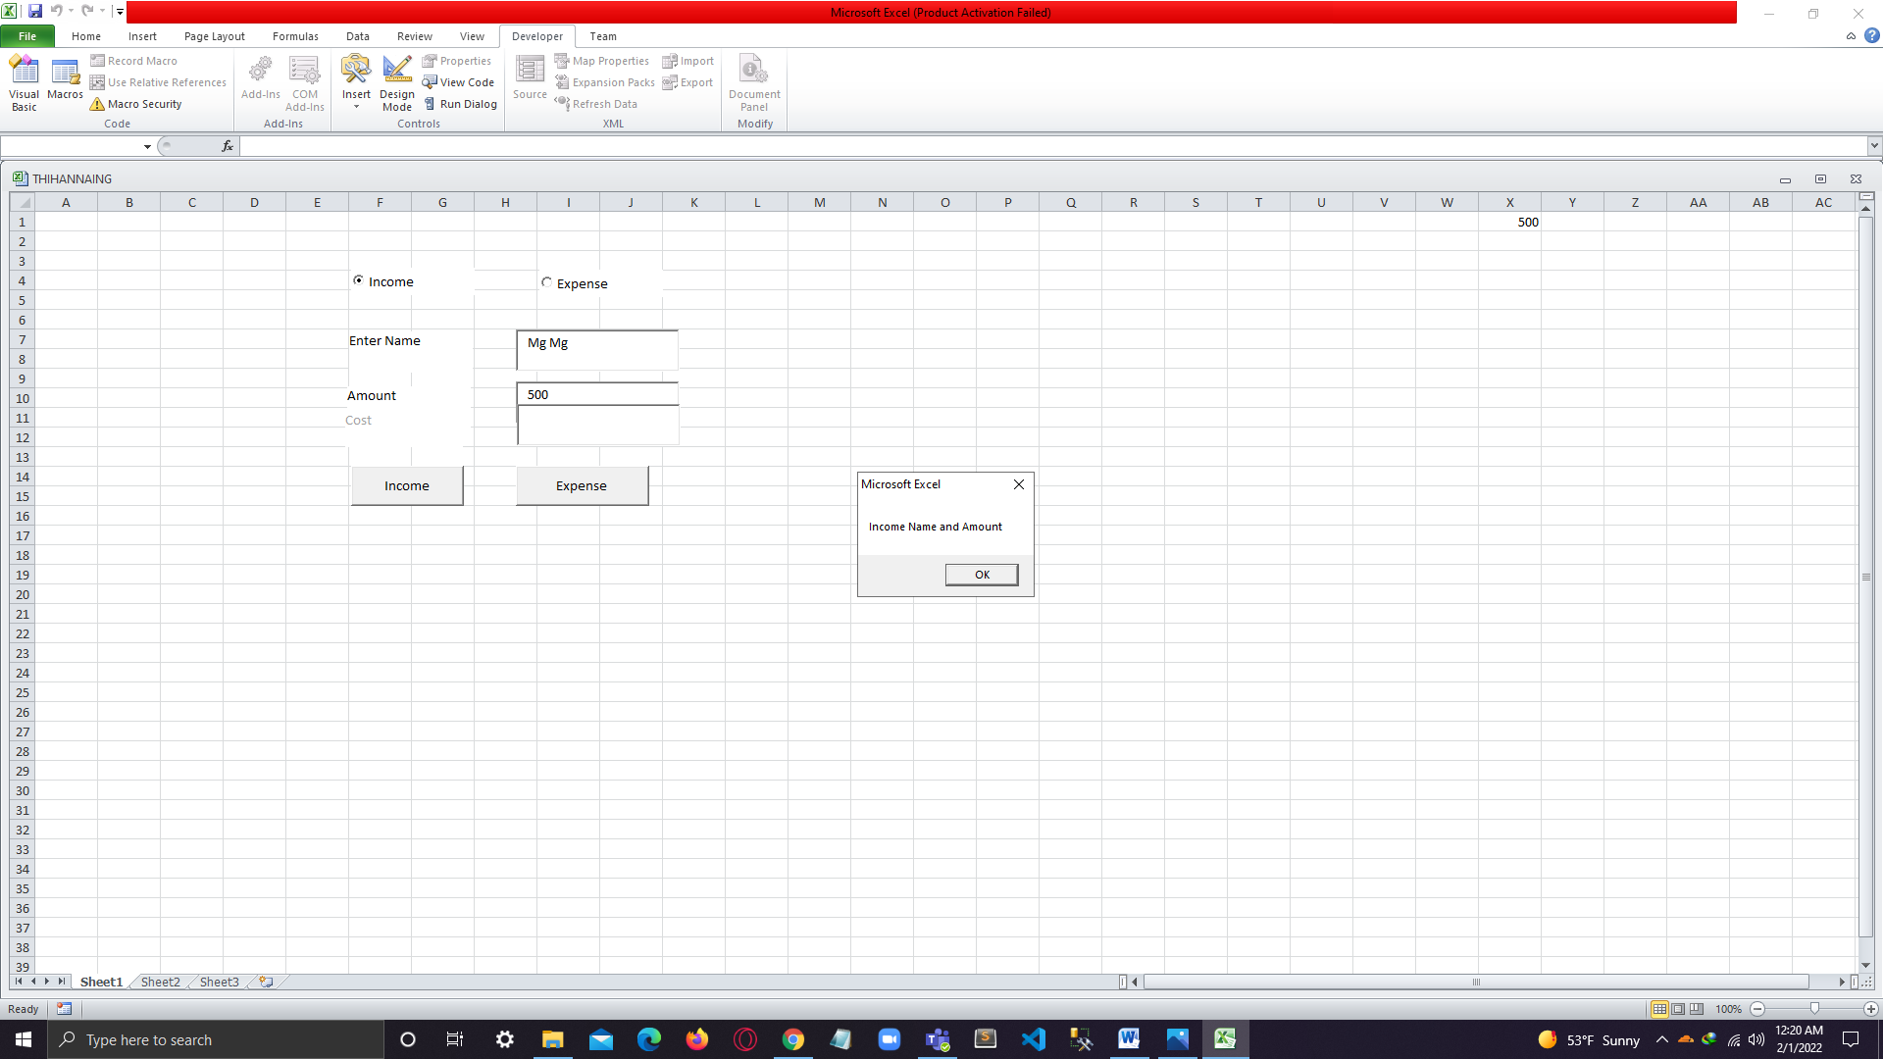

1. Adding data and showing the message box when clicking the expense button.

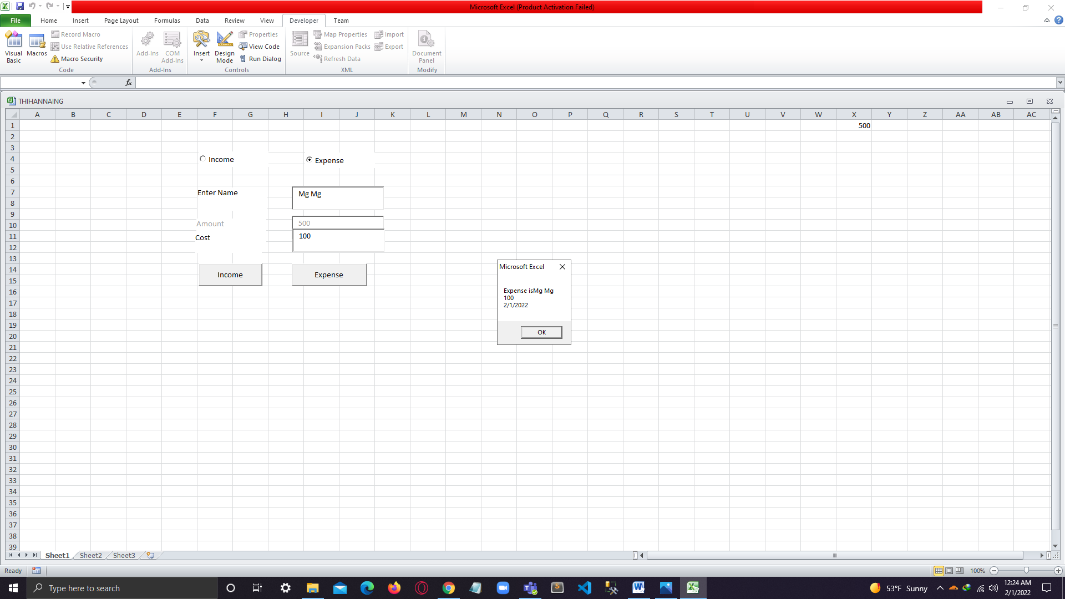

1. Replying with the message box.

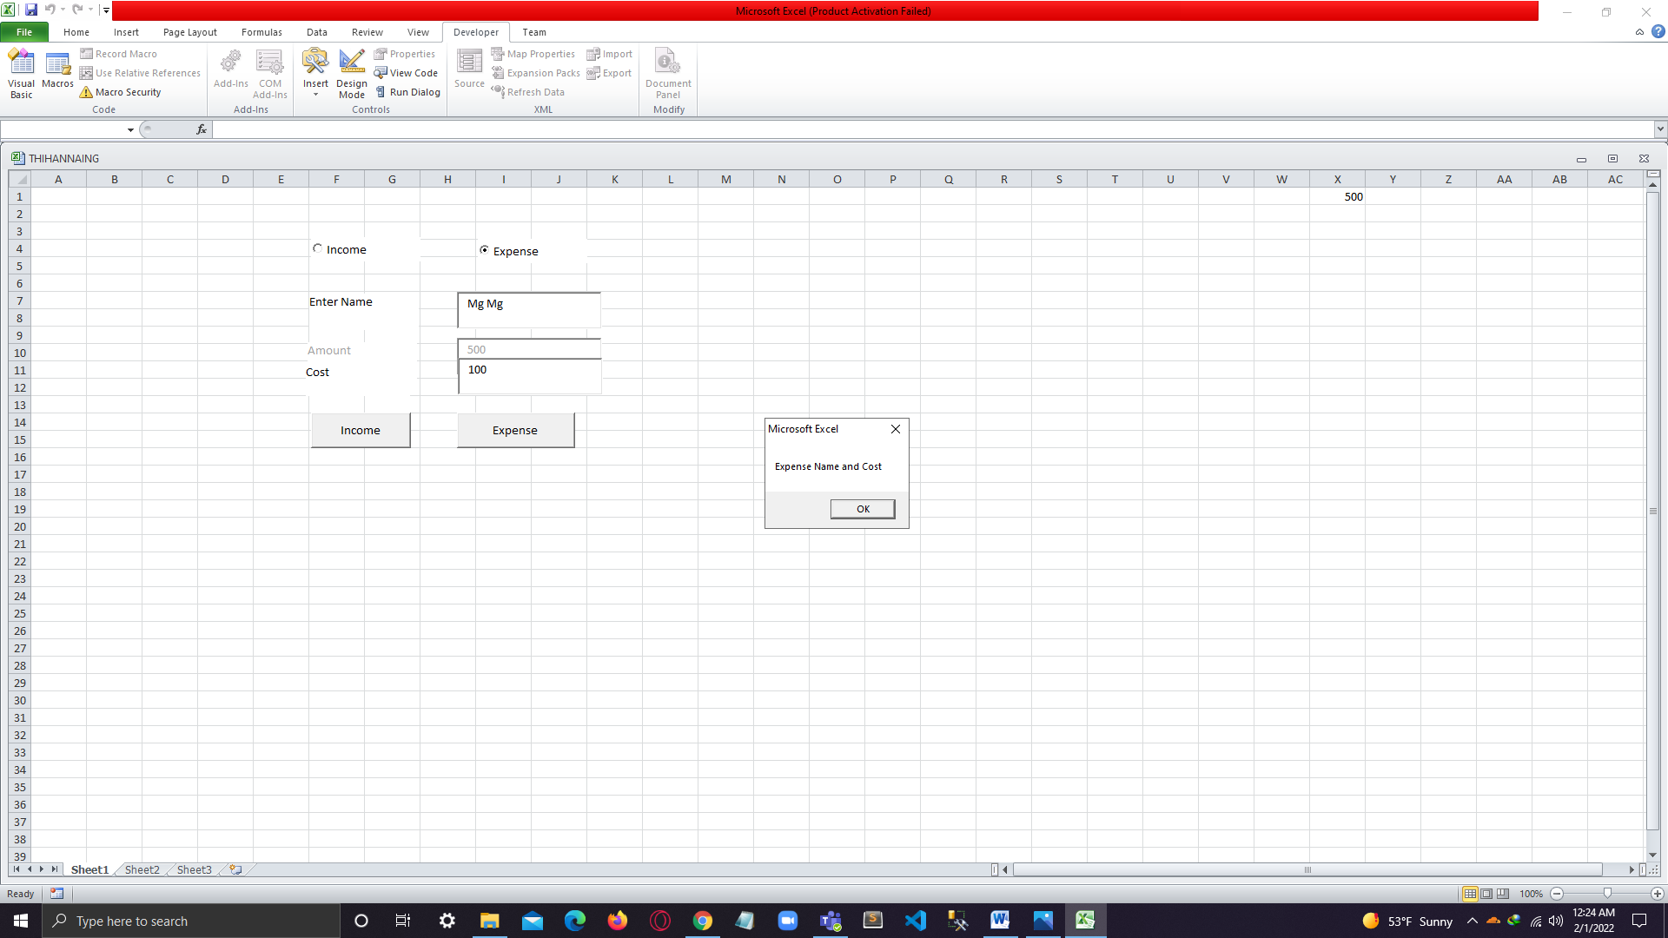

# References

# References

Anon., 2018. *top_advantages_bespoke_software.* [Online]   
Available at: https://www.arnia.com/top_advantages_bespoke_software  
[Accessed 2 October 2019].

Anon., 2021. [Online]   
Available at: https://document360.com/blog/software-documentation/

Anon., n.d. *Run a macro.* [Online]   
Available at: https://support.office.com/en-us/article/run-a-macro-5e855fd2-02d1-45f5-90a3-50e645fe3155  
[Accessed 7 October 2019].

Anon., n.d. *tyrocity.* [Online]   
Available at: https://tyrocity.com/topic/features-of-microsoft-excel/

Anon., n.d. *walkme.* [Online]   
Available at: https://www.walkme.com/glossary/software-implementation/

Anon., n.d. *What-are-the-types-of-application-software.* [Online]   
Available at: https://www.quora.com/What-are-the-types-of-application-software  
[Accessed 7 October 2019].

Basu, S., 2019. *10 Hidden Features of Microsoft Word That’ll Make Your Life Easier.* [Online]   
Available at: https://www.makeuseof.com/tag/10-hidden-microsoft-word-features-will-make-life-easier/  
[Accessed 7 October 2019].

Bridge, R., 2019. *Open source software: Advantages & disadvantages.* [Online]   
Available at: https://entrepreneurhandbook.co.uk/open-source-software/  
[Accessed 2 October 2019].

Commision, T. C., 2020. *GOV.UK.* [Online]   
Available at: https://www.gov.uk/guidance/managing-charity-finances

Doiphode, R., 2018. *What is the purpose of a mail merge and why are they used?.* [Online]   
Available at: https://www.quora.com/What-is-the-purpose-of-a-mail-merge-and-why-are-they-used  
[Accessed 7 October 2019].

Geeta, n.d. *SynapseIndia.* [Online]   
Available at: https://www.synapseindia.com/article/6-stages-of-software-development-process

Global, Q., n.d. *QAT Global.* [Online]   
Available at: https://www.qat.com/importance-business-analysis-software-development/

Heffernan, B., 2018. *TPP.* [Online]   
Available at: https://www.tpp.co.uk/blog/2018/10/working-in-charity-hr

Hill, H., 2019. *ThirdSector.* [Online]   
Available at: https://www.thirdsector.co.uk/decoding-job-description-fundraising-manager/careers/article/1484578

Joomla!, n.d. *What is the purpose of a template?.* [Online]   
Available at: https://docs.joomla.org/What_is_the_purpose_of_a_template%3F  
[Accessed 7 October 2019].

Kim, N., 2015. *Taylor&Francis Online.* [Online]   
Available at: https://www.tandfonline.com/doi/abs/10.2501/IJA-33-4-707-724

Matisha, S., 2013. *SocialMediaToday.* [Online]   
Available at: https://www.socialmediatoday.com/content/charitable-marketing-strategies-8-ideas-small-businesses

Mindbrower, n.d. *MiNBROWSER.* [Online]   
Available at: https://www.mindbowser.com/why-software-design-is-important/

Molina, F., 2020. *BairesDev.* [Online]   
Available at: https://www.bairesdev.com/blog/10-types-of-software-development-explained/

Morris, J., 2019. *givergy.* [Online]   
Available at: https://www.givergy.com/uk/blog/6-free-ways-to-promote-your-charity/

Reverchuk, L., n.d. *COMMERCIAL VS OPEN SOURCE SOFTWARE: BENEFITS AND DRAWBACKS.* [Online]   
Available at: https://echoua.com/commercial-vs-open-source-software-the-benefits-and-drawbacks/  
[Accessed 2 October 2019].

Scaffidi, M. M. a. C., n.d. *Interaction design foundation.* [Online]   
Available at: https://www.interaction-design.org/literature/book/the-encyclopedia-of-human-computer-interaction-2nd-ed/end-user-development

Shamil, P. R., n.d. *T4Tutorials.* [Online]   
Available at: https://t4tutorials.com/what-is-end-user-computing-examples-and-types-in-mis/

Team, i. E., 2021. *indeed.* [Online]   
Available at: https://www.indeed.com/career-advice/career-development/user-interface

Candidate checklist

|  |  |
| --- | --- |
| Have your read the NCC Education documents ‘What is Academic Misconduct? Guidance for Candidates’ and ‘Avoiding Plagiarism and Collusion: Guidance for Candidates’ and ensured that you have acknowledged all the sources that you have used in your word? | ✓ |
| Have you completed the ‘Statement and Confirmation of Own Work’ form and attached it to your assignment? | ✓ |
| Have you ensured that your work has not gone over or under the recommended word count by more than 10% | ✓ |
| Have you ensured that your work does not contain viruses and can be run directly? | ✓ |